#### A Project Report on

**Medical Image Segmentation for Brain Tumor DetectionUsing U-Net**

A Dissertation submitted to JNTU Hyderabad in partial fulfillment of the academic requirements for the award of the degree.

**Bachelor of Technology**

**In**

**Computer Science and Engineering**

Submitted by

VUYYURU NAMITHA (20H51A0580) AKSHAY TONDE (20H51A05K0)

JARPULA SIVAKUMAR

(20H51A05N8)

Under the esteemed guidance Mr. A. Vivekanand (Associate Professor)



**Department of Computer Science and Engineering**

### CMR COLLEGE OF ENGINEERING & TECHNOLOGY

(UGC Autonomous)

*Approved by AICTE *Affiliated to JNTUH *NAAC Accredited with A+ Grade

KANDLAKOYA, MEDCHAL ROAD, HYDERABAD - 501401.

### 2020- 2024

**CMR COLLEGE OF ENGINEERING & TECHNOLOGY**

KANDLAKOYA, MEDCHAL ROAD, HYDERABAD – 501401

DEPARTMENT OF COMPUTER SCIENCE AND ENGINEERING



### CERTIFICATE

This is to certify that the Major Project report entitled entitled **"Medical Image Segmentation for Brain Tumor Detection using U-Net”** being submitted by **V. Namitha (20H51A0580), K. Akshay Tonde (20H51A05K0), J. SivaKumar (20H51A05N8)** in

partial fulfillment for the award of **Bachelor of Technology in COMPUTER SCIENCE AND ENGINEERING** is a record of bonafide work carried out under my guidance and supervision. The results embodied in this project report have not been submitted to any other

University or Institute for the award of any Degree.

|  |  |  |
| --- | --- | --- |
| **Mr. A. Vivekanand**  Associate Professor | **Dr. Siva Skandha Sanagala**  Associate Professor and HOD | **EXTERNAL EXAMINER** |
| Dept. of CSE | Dept. of CSE |  |

### ACKNOWLEDGEMENT

With great pleasure, we want to take this opportunity to express our heartfelt gratitude to all the people who helped in making this project a grand success.

We are grateful to our guide **Mr. A. Vivekanand (Associate Professor)**, Department of Computer Science and Engineering for his valuable technical suggestions and guidance during the execution of this project work.

We would like to thank**, Dr. Siva Skandha Sanagala,** Head of the Department of Computer Science and Engineering, CMR College of Engineering and Technology, who is the major driving force to complete our project work successfully.

We are very grateful to **Dr. Ghanta Devadasu**, Dean-Academics, CMR College of Engineering and Technology, for his constant support and motivation in carrying out the project work successfully.

We are highly indebted to **Major Dr. V A Narayana,** Principal, CMR College of Engineering and Technology, for giving permission to carry out this project in a successful and fruitful way.

We would like to thank the **Teaching & Non- teaching** staff of Department of Computer Science and Engineering for their co-operation.

We express our sincere thanks to **Shri. Ch. Gopal Reddy**, Secretary& Correspondent, CMR Group of Institutions, and **Shri. Ch. Abhinav Reddy**, CEO, CMR Group of Institutions for their continuous care and support.

Finally, we extend thanks to our parents who stood behind us at different stages of this Project. We sincerely acknowledge and thank all those who gave support directly or indirectly in completion of this project work.

V. NAMITHA - 20H51A0580

T. AKSHAY - 20H51A05K0

J. SIVAKUMAR - 20H51A05N8

**TABLE OF CONTENTS**

**CHAPTER NO. TITLE PAGE NO.**

|  |  |  |
| --- | --- | --- |
| LIST OF FIGURES LIST OF TABLES ABSTRACT  **1 INTRODUCTION** | | iii iv  v  **1-6** |
|  | * 1. Introduction   2. Problem Statement | 2  4 |
|  | 1.3 Research Objective | 4 |
|  | 1.4 Project Scope and Limitations | 5 |
| **2 BACKGROUND WORK** | | **7-11** |
|  | 2.1. Manual Segmentation | 8 |
|  | 2.1.1. Introduction | 8 |
|  | 2.1.2. Merits, Demerits and Challenges | 8 |
|  | 2.1.3. Implementation | 8 |
|  | 2.2. Thresholding and Region Growing | 9 |
|  | 2.2.1. Introduction | 9 |
|  | 2.2.2. Merits, Demerits and Challenges | 9 |
|  | 2.2.3. Implementation | 9 |
|  | 2.3. Region-Based Active Contour Models | 10 |
|  | 2.3.1. Introduction | 10 |
|  | 2.3.2. Merits, Demerits and Challenges | 10 |
|  | 2.3.3. Implementation | 10 |
|  | 2.4 Comparison Table | 11 |
| **3** | **PROPOSED SYSTEM** | **12-30** |
|  | 3.1 U-net’s Algorithm  3.2. Proposed System | 13  15 |
|  | * 1. System Design   2. Project Implementation | 16  24 |
| **4** | **RESULTS & DISCUSSIONS** | **31-32** |
|  | 4.1. Results Obtained | 32 |

|  |  |  |
| --- | --- | --- |
| **5** | **CONCLUSION** | **33-34** |
|  | 5.1. Conclusion | 33 |

|  |  |  |
| --- | --- | --- |
| **6** | **REFERENCES** | **35-37** |
|  | 6.1. References | 35 |
| **7** | **APPENDIX** | **38-44** |
|  | 7.1. Project Code | 38 |

|  |  |  |
| --- | --- | --- |
| **8** | **GITHUB LINK** | **45** |
| **9** | **DOI** | **45** |
| **10** | **PUBLISHED PAPER** | **46-55** |
| **11** | **CERTIFICATES** | **56-59** |

MEDICAL IMAGE SEGMENTATION FOR BRAIN TUMOR DETECTION USING U-NET

#### List of Figures

**FIGURE NO. TITLE PAGE NO.**

|  |  |  |
| --- | --- | --- |
| 3.1.1  3.3.1  3.3.2  3.3.3  3.3.4  3.3.5  3.3.6  3.3.7  3.3.8  3.4.1  3.4.2  3.4.3  3.4.4  3.4.5  3.4.6  3.4.7  3.4.8  3.4.9  3.4.10  3.4.11  3.4.12  3.4.13  4.1.1 | U-net’s Algorithm System Architecture Class Diagram  Use case Diagram Sequence Diagram Component Diagram Deployment Diagram Activity Diagram Dataflow Diagram Dataset Folder Contents of Folder Sample Dataset Contents of Sample User Interface Uploading Dataset Dataset Uploaded Generating Model Output Shape Params  Uploading Sample Dataset Segmentation of MRI Scans Uploading sample Dataset Segmentation of sample dataset  Dice Score Graph | 13  16  17  18  19  20  21  22  23  24  24  25  25  26  26  27  27  28  28  29  30  30  32 |

MEDICAL IMAGE SEGMENTATION FOR BRAIN TUMOR DETECTION USING U-NET

#### ABSTRACT

Brain tumors encompass a wide spectrum of growths that can occur within the cranial cavity. These tumors may be benign or malignant, and their early detection is vital for initiating timelymedical interventions. MRI, a non-invasive imaging modality, provides detailed anatomical information, making it an invaluable tool for diagnosing and monitoring brain tumors. However,the accurate identification of tumor boundaries from complex MRI data remains a complex anddemanding task. The project utilizes a sophisticated image segmentation method to automatically identify and outline tumor regions in MRI scans. The technique is based on the principles of deep learning, a subset of artificial intelligence, which enables computers to learn and recognize patterns from large datasets. This learning process enables the algorithm to distinguish between healthy brain tissue and abnormal tumor growths, aiding medical professionals in making informed decisions. The U-Net architecture's unique design, characterized by a U-shaped structure with contracting and expansive paths, enables it to effectively capture intricate structures and fine-grained details in medical images. Leveraging adiverse dataset of multi-modal brain MRI scans, the U-Net algorithm is trained to automaticallysegment tumor regions, providing pixel-level precision.

# CHAPTER 1

## INTRODUCTION

### CHAPTER 1 INTRODUCTION

###### 1.1. INTRODUCTION

Medical image segmentation is a crucial task in modern healthcare, facilitating the precise delineation of anatomical structures from various imaging modalities. Magnetic Resonance Imaging (MRI), known for its high-resolution visualization, plays a pivotal role in clinical diagnostics. However, manual segmentation of MRI images is time-consuming and subjective, highlighting the need for automated approaches. One notable algorithm in this domain is the U- Net architecture, introduced by Ronneberger et al. in their seminal work "U-Net: Convolutional Networks for Biomedical Image Segmentation" (Ronneberger, 2015) [1]. The U-Net's unique encoder-decoder design is adept at accurately localizing and segmenting intricate anatomical structures, making it highly suitable for medical image analysis.The U-Net architecture utilizesan encoder to extract contextual information and abstract features, while the decoder refines localization through up-sampling and feature concatenation. This structure enables U-Net to deliver precise segmentations, even in complex anatomical regions.Automated segmentation has shown significant promise in transforming medical image analysis, with U-Net emerging as a powerful tool in this field. The adoption of deep learning techniques in medical imaging has also received considerable attention, further emphasizing the importance of this project (Litjenset al., 2017 [2]; Greenspan et al., 2016 [3]).Accurate segmentation of tumors through medical images is particularly important as it provides essential information for the analysis anddiagnosis of cancer, as well as for planning treatment options and monitoring disease progression. Brain tumors, among the deadliest cancers worldwide, are categorized into primaryand secondary types based on their origin. The most common histological type of primary braincancer is glioma, which originates from the brain's glial cells and accounts for 80% of all malignant brain tumors. Gliomas can be slow-progressing low-grade (LGG), which have a betterprognosis, or the more aggressive and infiltrative high-grade gliomas (HGG) or glioblastomas,requiring immediate treatment. These tumors are associated with significant morbidity, with the median survival for a patient with glioblastoma being only about 14 months and a 5-year survival rate near zero despite maximal surgical and medical therapy. Thus, timely diagnosis iscrucial for effective treatment MRI is a preferred technique widely used by radiologists for evaluating and assessing brain tumors. Wu, B., et al. (2024) [4] It provides several complementary 3D MRI modalities based on different degrees of excitation and repetition times,i.e., T1-weighted, post-contrast T1-weighted (T1ce), T2- weighted, and Fluid-Attenuated Inversion Recovery (FLAIR). The highlighted subregions of the

tumor across different intensities of these sequences, such as the whole tumor (inclusive of infiltrative edema), are more prominent in FLAIR and T2 modalities, while T1 and T1ce images show the tumor core exclusive of peritumoral edema. This allows for the combined use of these scans and the complementary information they provide for detecting different tumor subregions.The Multimodal Brain Tumor Segmentation Challenge (BraTS) offers a platform to evaluate the development of machine learning models for tumor segmentation by providing participants withan extensive dataset of 3D MRI images of gliomas (both LGG and HGG) and associated groundtruths annotated by expert physicians. Nguyen, P. X., et al. (2019) [5] The multimodal scans areused for training and validating neural networks designed for this specific segmentation task. Manual delineation of brain tumor sub regions from MRI scans is subjective, time-consuming, and prone to variability. Therefore, automated segmentation of gliomas from multimodal MRI images can assist physicians in speeding up diagnosis and surgical planning, providing an accurate, reproducible solution for further tumor analysis and monitoring. Classical methods ofautomated brain tumor segmentation rely on feature engineering, which involves extracting handcrafted features from input images followed by classifier training. In contrast, unsupervisedlearning algorithms and deep learning models excel by automatically learning a hierarchy of feature representation, with Convolutional Neural Networks (CNNs) regarded as the state-of- the-art methods for brain tumor image segmentation. They automatically learn the most useful and relevant features. However, accurate segmentation of tumors remains challenging due to theheterogeneity in shape, size, and appearance of gliomas, as well as the ambiguous and fuzzy boundaries between cancer and brain tissue. Huang, C., et al. (2019) [6] The intensity variabilityof MRI data further complicates this issue. Therefore, there is room for improvement and further exploration for better segmentation techniques and accuracy. In this work, we utilize multiple 3D CNN models for brain tumor segmentation from multimodal MRI scans and ensemble their probability maps for more stable predictions. Lu, H., et al. (2022) [7] The networks are trained separately, with hyper parameters optimized for each model, on the training dataset acquired from the 2019 Brain Tumor Segmentation (BraTS) challenge. A rigorous evaluation on the BraTS validation set resulted in the proposed ensemble achieving Dice scores of 0.750, 0.906, and 0.846 forenhancing tumor, whole tumor, and tumor core, respectively.

###### PROBLEM STATEMENT

The accurate identification and delineation of tumor boundaries in complex MRI data remains a challenging task. Early detection of brain tumors is crucial for timely medical interventions. While MRI is a valuable non-invasive imaging modality, manual segmentation of tumor regionsis time- consuming and prone to human error. Therefore, there is a pressing need for an automated and accurate method to identify and outline tumor regions in MRI scans, facilitating more efficient diagnosis and monitoring of brain tumors. This project aims to address this challenge by employing a sophisticated image segmentation technique based on deep learning principles, specifically utilizing the U-Net architecture, to achieve pixel-level precision in segmenting tumor regions.

###### RESEARCH OBJECTIVE

Automated segmentation of brain tumors from multimodal MR images is crucial for analyzing and monitoring disease progression. Gliomas, known for their malignancy and heterogeneity, necessitates efficient and precise segmentation techniques for the successful delineation of tumors into intra-tumoral classes. Deep learning algorithms excel in tasks of semantic segmentation, surpassing more traditional, context-based computer vision approaches. Widely employed for biomedical image segmentation, Convolutional Neural Networks (CNNs) have notably enhanced the accuracy of brain tumor segmentation. In this paper, we introduce an ensemble of two segmentation networks: a 3D CNN and a U-Net, employing a simple yet effective combinative approach that yields improved and more precise predictions. Both models were trained independently on the BraTS-19 challenge dataset and evaluated, producing segmentation maps that significantly varied from each other in terms of segmented tumor sub- regions. These maps were then combined in a novel manner to achieve the final prediction. Ourproposed ensemble achieved Dice scores of 0.750, 0.906, and 0.846 for enhancing tumor, wholetumor, and tumor core, respectively, on the validation set. This performance is favorable in comparison to the current state-of-the-art architectures available.

###### PROJECT SCOPE

* + 1. Objective: The project aims to develop an automatic brain tumour segmentation system using the U-Net deep learning architecture applied to multi-modal MRI scans. This system will assist in the accurate identification and outlining of tumour regions within the cranial cavity.
    2. Medical Imaging Focus: The project focuses on the use of MRI scans as the primary source of medical imaging data. It intends to enhance the precision of brain tumour segmentation within these scans.
    3. Deep Learning and U-Net: The project utilizes deep learning techniques, particularly theU- Net architecture, to automatically detect and outline tumour regions. U-Net's unique design is leveraged for its ability to capture intricate structures and fine-grained details in medical images.
    4. Dataset Utilization: The project involves the use of a diverse dataset of multi-modal brain MRI scans for training the U-Net algorithm. The dataset is essential for enabling the algorithm to distinguish between healthy brain tissue and abnormal tumour growths effectively.

**Limitations:**

1. Data Availability: The project's success heavily relies on the availability of high-quality and diverse MRI datasets. The accuracy of the segmentation model is limited by the quality and representativeness of the training data.
2. Algorithm Generalization: The deep learning model, while powerful, may not generalize well to all possible variations in tumour appearances. Its effectiveness in segmenting different types and sizes of tumours is subject to the quality and diversity of the training data.
3. Performance Dependency: The performance of the system is dependent on the quality and resolution of the MRI scans. Lower-quality scans may yield less accurate segmentation results.
4. Algorithm Computation: The computational resources required for training and running deep learning models can be substantial. The project may be limited by the availability of such resources.
5. Human Oversight: Although the project aims to automate the tumour segmentation process, it is important to note that the results produced by the algorithm may still require

human oversight and validation, particularly in a clinical setting.

1. Legal and Ethical Considerations: The project may be subject to legal and ethical considerations, including patient consent, data privacy, and regulatory compliance when working with medical imaging data. These considerations may influence the implementation and deployment of the system.
2. Clinical Integration: The integration of the developed system into clinical practice may have limitations related to compatibility with existing healthcare infrastructure and the willingness of medical professionals to adopt and trust the technology.
3. Ongoing Research: The project may not cover all possible nuances and complexities of brain tumour segmentation, and it is subject to ongoing research and advancements in the field of medical imaging and deep learning.

# CHAPTER 2

## BACKGROUND

**WORK**

### CHAPTER 2 BACKGROUND WORK

###### Manual Segmentation:

* + 1. **Introduction**

In this section we have studied various implementation of Medical image segmentation using U-net’s algorithm and we have summarized our findings that we concluded by researching and referencing various papers. They are as below.

###### Merits, Demerits, and Challenges Merits:

* + - * **High Accuracy**: Manual segmentation is Arora, A., et al. ( 2021 ) [ 8 ] capable of achieving high levels of accuracy,especially when tumors are well- defined in the scans.
      * **Clinical Expertise**: Radiologists can make clinical judgments during the segmentationprocess, taking into account a patient's medical history and context.

###### Demerits:

* + - * **Subjective Variability**: The accuracy can vary between different experts, leading to inter-and Yin, X. X., et al. (2022) [9] intra-observer variability.
      * **Time-Consuming**: Manual segmentation is a time-consuming process, which may not besuitable for situations requiring rapid decision-making.

###### Challenges:

* + - * **Variability**: Variability in segmentations can lead to differences in treatment decisions.Resource-Intensive: It requires skilled human Sun, J., et al. (2020) [10] resources and is often impractical for large-scale applications.

###### Implementation

Radiologists use specialized medical imaging software to manually draw and outline tumor boundaries. The process is labor-intensive and typically integrated into the clinical workflow.

* 1. **Thresholding and Region Growing:**

###### Introduction

Thresholding and region growing are traditional computer-assisted methods for tumor segmentation. They rely on intensity thresholds and spatial information to classifyand segment tumor regions in MRI scans.

###### Merits, Demerits and Challenges Merits:

**Demerits:**

###### Challenges:

**Simplicity**: These methods are Jwaid, W. M., et al [11] relatively straight forward to implement and do not require extensive computational resources.

**Speed:** Depending on the specific technique, they can provide relatively fast results.

**Complex Cases**: Nguyen, P. X., et al [12] These methods may struggle with complextumor shapes, heterogeneousappearances, or small lesions.

**Noise Sensitivity**: MRI scans can contain noise, leading to inaccurate segmentations withthese methods.

**Accuracy:** Achieving high accuracy, especially for intricate or irregular tumor shapes, can be challenging.

**Robustness**: The methods may not adapt well to variations in MRI scan quality orpathology.

##### Implementation

Thresholding methods use intensity thresholds to classify pixels as tumor or non-tumor. Region growing algorithms start from seed points and expand regions based on pixel similarity. These techniques are typically implemented using image processing libraries and tools.

##### Region-Based Active Contour Models:

###### Introduction

Region-based active contour models, also known as snakes, are segmentation methods that use deformable models to iteratively adjust contours to segment objects of interest, such as brain tumors.

###### Merits, Demerits and Challenges Merits:

* + - * **Adaptability**: Zheng, P., et al. (2022) [13] These models can adapt to varying tumor shapes and sizes.
      * **Object Interaction**: They can handle multiple objects in the image and segment themindividually.

##### Demerits:

* + - * **Initialization Sensitivity**: The accuracy of the segmentation can be sensitive to the initialcontour placement.
      * **Computational Load**: These S u n , J , e t a l . [ 14 ] models can be computationallyintensive, particularly for real-time applications.

##### Challenges:

* **Initialization:** Proper initialization of the contour is crucial for accurate results.
* **Computational Resources**: Implementing these models can require significant computational resources.

##### Implementation

Active contour models use energy minimization to iteratively adjust contours. The initialization of the contour is a critical step in the segmentation process. These models can be implemented using various image analysis and computer vision libraries.

##### Comparison Table

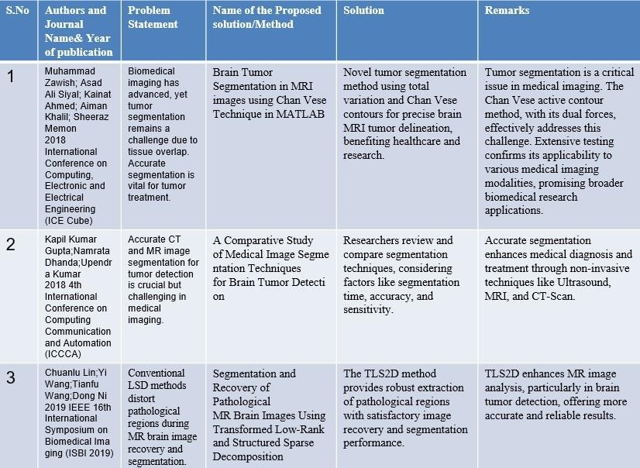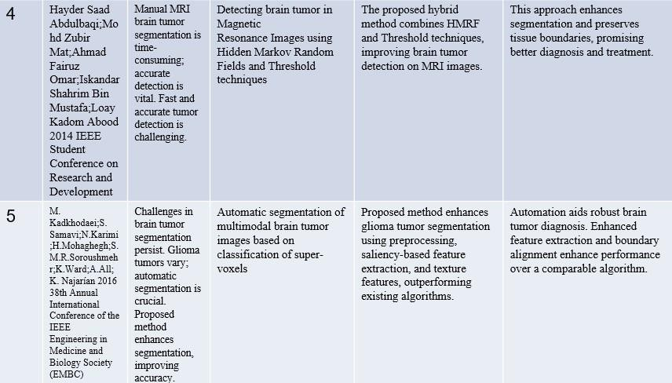

(Table 2.4.1 Comparision Table of various research papers)

# CHAPTER 3

## PROPOSED SYSTEM

### CHAPTER 3 PROPOSED SYSTEM

###### U-net’s Algorithm:

U-Net is a convolutional neural network (CNN) architecture that was designed for biomedical image segmentation, including tasks such as brain tumor segmentation. Originally introduced by Olaf Ronneberger, Philipp Fischer, and Thomas Brox in their paper "U-Net: Convolutional Networks for Biomedical Image Segmentation," U-Net has become a popular choice due to its efficiency and effectiveness in handling a variety of segmentation tasks, especially when dealing with a limited amountof data.

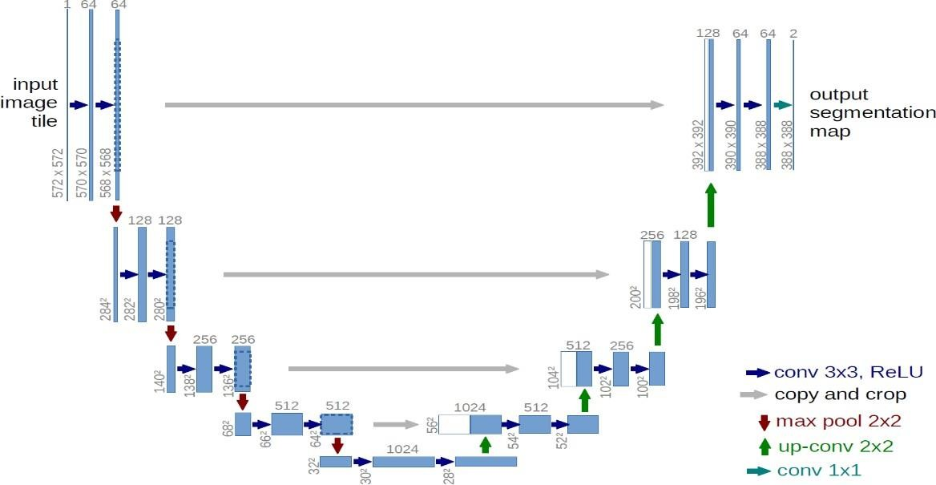

(Fig:3.1.1 U-net’s Architecture)

###### Key Features of U-Net:

**Symmetrical Structure:** The architecture resembles the letter "U," which is the origin of its name. This structure comprises a contracting path to capture context and a symmetric expanding path that enables precise localization.

**Contracting Path:** The left side of the U, which is responsible for capturing the context in the image. It consists of a series of convolutional and max pooling layers that reduce the spatial dimensions of theinput image while increasing the feature maps.

**Expanding Path:** The right side of the U, which is responsible for precise localization, using transposed convolutions to increase the resolution of the output. This path also includes concatenation with corresponding feature maps from the contracting path to ensure that the network can use features from

both local and global context.

**Skip Connections:** These are crucial for the U-Net architecture. They connect feature maps from the contracting path to the expanding path, helping the network to recover the spatial information lost during down sampling.

Fewer Training Samples: U-Net is designed to work well even with a very small number of training images, leveraging extensive data augmentation techniques to enhance the training set.

###### Structure of U-Net:

The structure of U-Net can be divided into two main parts: the contracting/down sampling path and the expanding/up sampling path.

**Contracting Path**: It typically starts with an input image passed through repeated blocks of two 3x3 convolutions followed by a rectified linear unit (ReLU) activation function, and then a 2x2 max pooling operation with stride 2 for down sampling. At each down sampling step, the number of feature channels is doubled.

**Bottleneck:** This is the bridge between the contracting and expanding paths. It usually consists of two 3x3 convolutions, each followed by a ReLU.

**Expanding Path:** Each step in the expanding path consists of an up sampling of the feature map followed by a 2x2 convolution (“up-convolution”) that halves the number of feature channels, a concatenation with the correspondingly cropped feature map from the contracting path, and two 3x3 convolutions, each followed by a ReLU. The cropping is necessary due to the loss of border pixels in every convolution.

**Output Layer:** Finally, a 1x1 convolution is used to map each 64-component feature vector to the desired number of classes. In the case of binary segmentation, such as distinguishing the tumor from the non- tumor region, the output layer would have a single channel.

###### Proposed System:

To implement this project we are using 4 different images these images are called FLAIR, T1, T2, and T1CE, and the label segmented image. The multi-institutional dataset, acquired from 19 different contributors, contains multimodal MRI scans of each patient, namely T1, T1 contrast-enhanced (T1ce), T2-weighted (T2), and Fluid Attenuated Inversion Recovery (FLAIR), from which the tumoural sub- regions are segmented. The data is processed to overcome discrepancies such that they are skull- stripped.

###### Advantage:

* + 1. More Accuracy.

**Modules:**

1. Upload BRATS Dataset
2. Generate CNN & UNET Model
3. Upload Test Image & Segmentation
4. Dice Similarity Graph

###### Upload BRATS Dataset:

Upload BRATS Dataset is the first module of our project, it is used to upload the BRATS dataset.

###### Generate CNN & UNET Model:

Generate CNN & UNET Model is the second module of our project, it is used to models and console to see CNN and UNET layer details. we can see models are using different size images to filter them and to get the best features from it to build an efficient model and now the model is generated.

###### Upload Test Image & Segmentation:

Upload Test Image & Segmentation is the third module of our project and then upload test samples to get segmented output. selecting and uploading the ‘Sample1’ folder and then clicking on ‘Select Folder’button to get the below output top 4 images are the input images such as FLAIR, T1, T2, and T1CE and5th image is the predicted image with the segmented part showing in red color and this algorithm correctly detecting and marking tumor area and now test with another image.

###### Dice Similarity Graph:

To build the CNN and UNET model we took 50 epochs or iterations and at each iteration DICE score between training and testing images got better and better and we got final dice score of 0.8 * 100 = 80%. In above graph x-axis represents epoch and y-axis represents dice score.

* 1. **System Design**

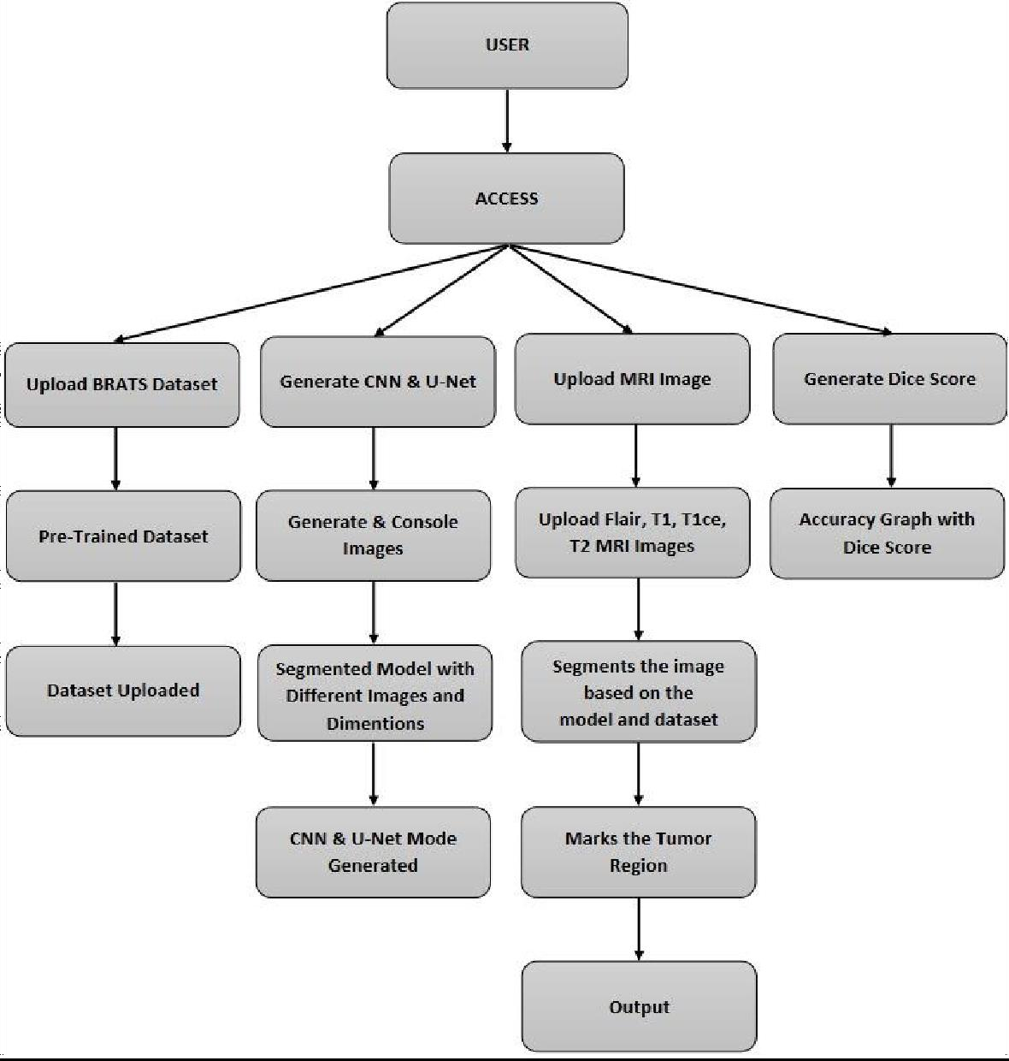

(Fig:3.3.1 System Architecture)

###### Class Diagram:

The class diagram is the main building block of object-oriented modeling. It is used both for general conceptual modeling of the systematics of the application and for detailed modeling translating the models into programming code. Class diagrams can also be used for data modeling. The classes in a class diagram represent both the main objects, interactions in the application and the classes to be programmed. In the diagram, classes are represented with boxes which contain three parts:

* The upper part holds the name of the class
* The middle part contains the attributes of the class
* The bottom part gives the methods or operations the class can take or undertake.

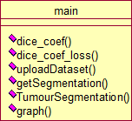

(Fig: 3.3.2 Class Diagram)

###### Use case Diagram:

A use case diagram at its simplest is a representation of a user's interaction with the system and depicting the specifications of a use case. A use case diagram can portray the different types of users ofa system and the various ways that they interact with the system. This type of diagram is typically used in conjunction with the textual use case and will often be accompanied by other types ofdiagrams as well.

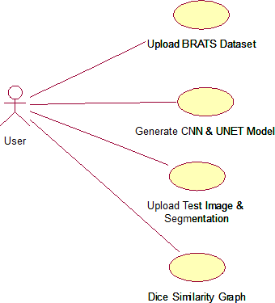

(Fig: 3.3.3 Use Case Diagram)

###### Sequence Diagram:

A sequence diagram is a kind of interaction diagram that shows how processes operate with one another and in what order. It is a construct of a Message Sequence Chart. A sequence diagram shows object interactions arranged in time sequence. It depicts the objects and classes involved in the scenario and the sequence of messages exchanged between the objects needed to carry out the functionality of the scenario. Sequence diagrams are typically associated with use case realizations in the Logical Viewof the system under development. Sequence diagrams are sometimes called event diagrams, event scenarios, and timing diagrams.

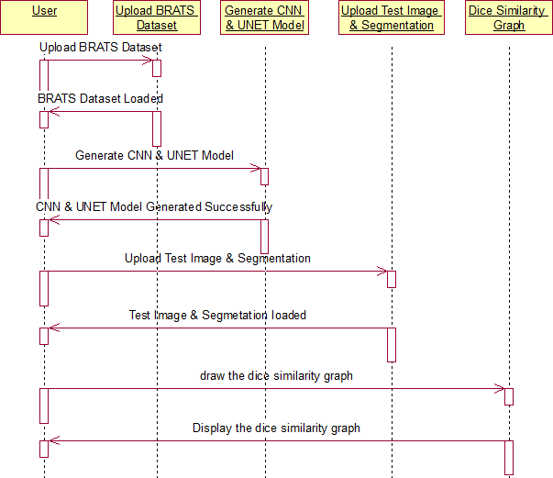

(Fig: 3.3.4 Sequence Diagram)

###### Component Diagram:

In the Unified Modeling Language, a component diagram depicts how components are wired together to form larger components and or software systems. They are used to illustrate the structure of arbitrarily complex systems.

Components are wired together by using an assembly connector to connect the required interfaceof one component with the provided interface of another component. This illustrates the service consumer - service provider relationship between the two components.

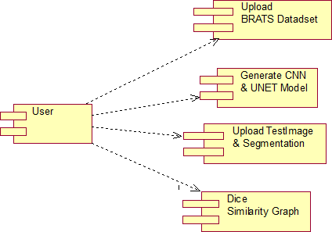

(Fig: 3.3.5 Component Diagram)

###### Deployment Diagram:

A deployment diagram in the Unified Modeling Language models the *physical* deployment of artifacts on nodes. To describe a website, for example, a deployment diagram would show what hardware components ("nodes") exist (e.g., a web server, an application server, and a database server),what software components ("artifacts") run on each node (e.g., web application, database), and how thedifferent pieces are connected (e.g. JDBC, REST, RMI).

The nodes appear as boxes, and the artifacts allocated to each node appear as rectangles withinthe boxes. Nodes may have sub-nodes, which appear as nested boxes. A single node in a deployment diagram may conceptually represent multiple physical nodes, such as a cluster of database servers.

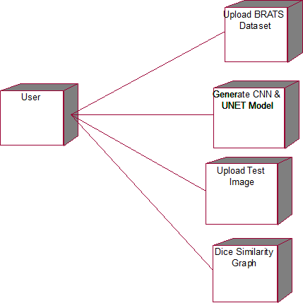

(Fig: 3.3.6 Deployment Diagram)

###### Activity Diagram:

The activity diagram is another important diagram in UML to describe the dynamic aspects of the system. It is a flow chart to represent the flow from one activity to another activity. The activity canbe described as an operation of the system. So, the control flow is drawn from one operation to another.This flow can be sequential, branched, or concurrent.

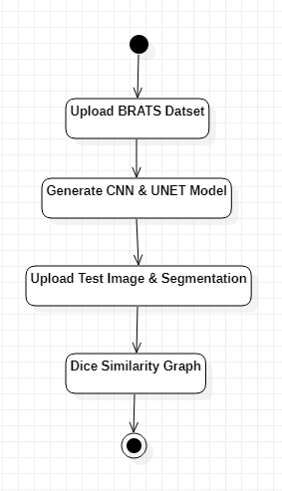

(Fig: 3.3.7 Activity Diagram)

###### Data Flow Diagram:

Data flow diagrams illustrate how data is processed by a system in terms of inputs and outputs. Data flow diagrams can be used to provide a clear representation of any business function. The technique starts with an overall picture of the business and continues by analyzing each of the functional areas of interest. This analysis can be carried out in precisely the level of detail required. The technique exploits a method called top-down expansion to conduct the analysis in a targeted way. As the name suggests, Data Flow Diagram (DFD) is an illustration that explicates the passage of information in a process. A DFD can be easily drawn using simple symbols.

Additionally, complicated processes can be easily automated by creating DFDs using easy-to-use, free downloadable diagramming tools. A DFD is a model for constructing and analyzing information processes. DFD illustrates the flow of information in a process depending upon the inputs and outputs.A DFD can also be referred to as a Process Model. A DFD demonstrates a business or technical processwith

the support of the outside data saved, plus the data flowing from one process to another and the results.

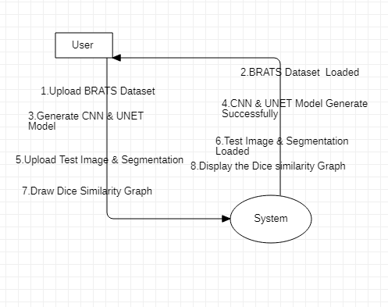

(Fig: 3.3.8 Data flow Diagram)

###### Project Implementation:

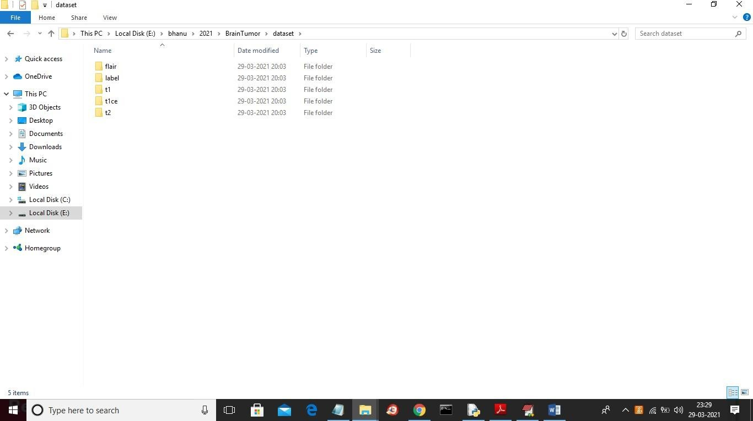BRATS dataset images are saved inside the dataset folder and in the below screen you can see the dataset content.

(Fig: 3.4.1 Dataset Folder)

In the above screen we have different format images and you can go inside any folder to see images

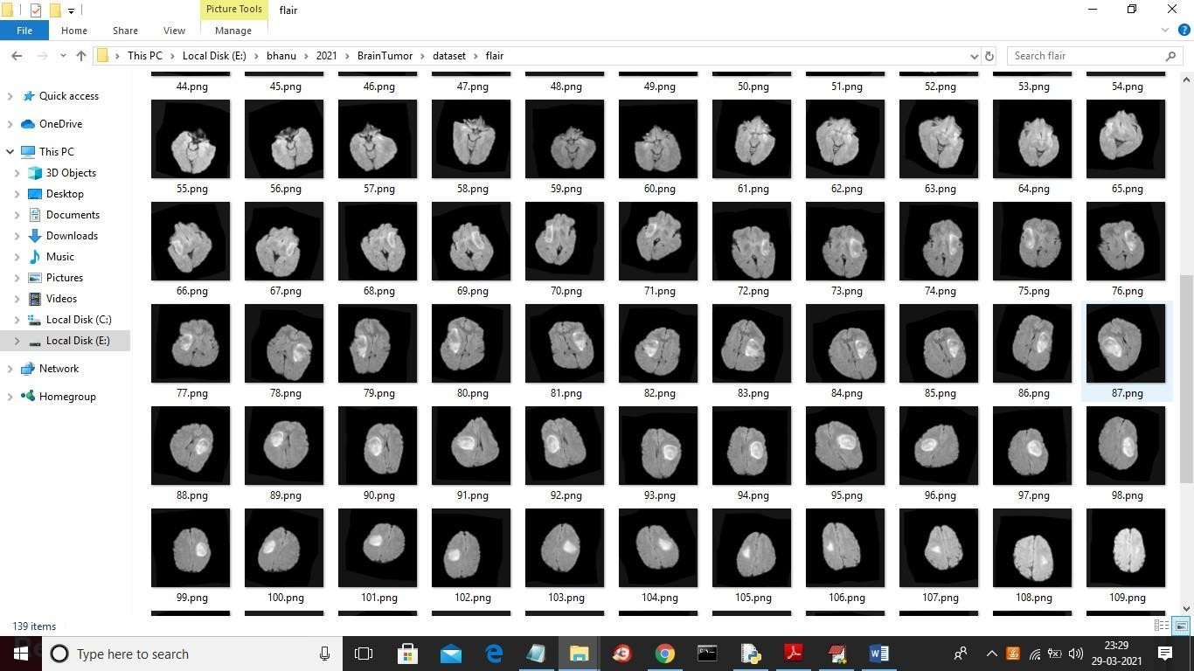

(Fig: 3.4.2 Contents of folder)

The above dataset is used to train the CNN and UNET model.

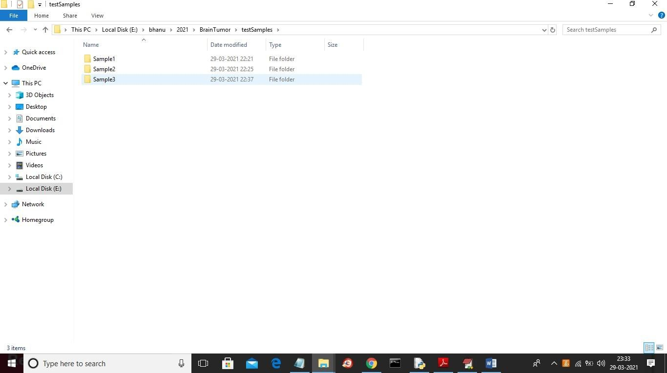After building UNET and CNN models we will upload test images from the ‘test samples’ folder and then the UNET model will give us segmented images. Below screenshots showing the test sample image.

(Fig:3.4.3 Sample Dataset)

In the above screen we have 3 sample images and now go inside any folder to get the below images.

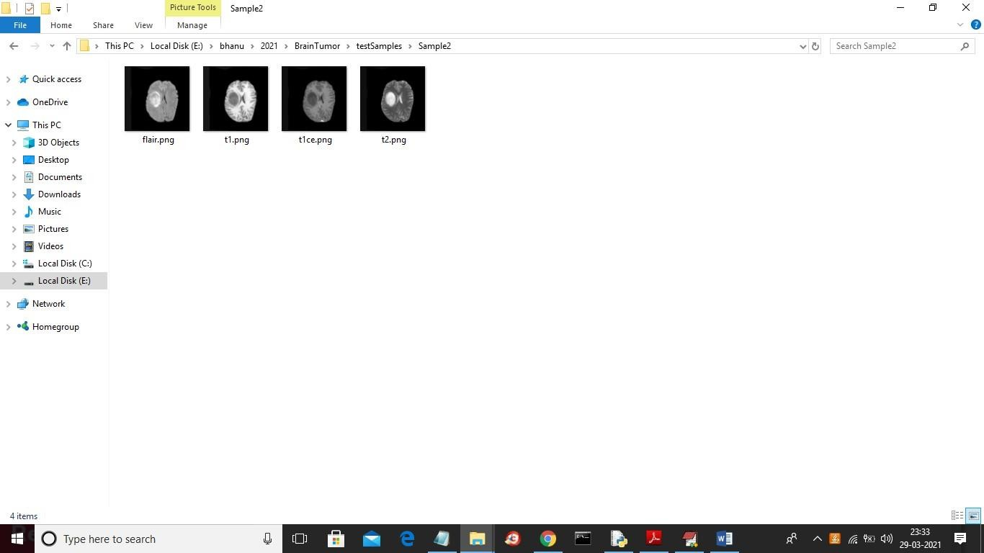

es

(Fig:3.4.4 Contents of sample)

In the above screen, we have FLAIR, T1, TICE and T2 images but we don’t have segmented label image after applying model on the above images then we will get segmented label image.

To run the project double click on the ‘run.bat’ file to get the below screen

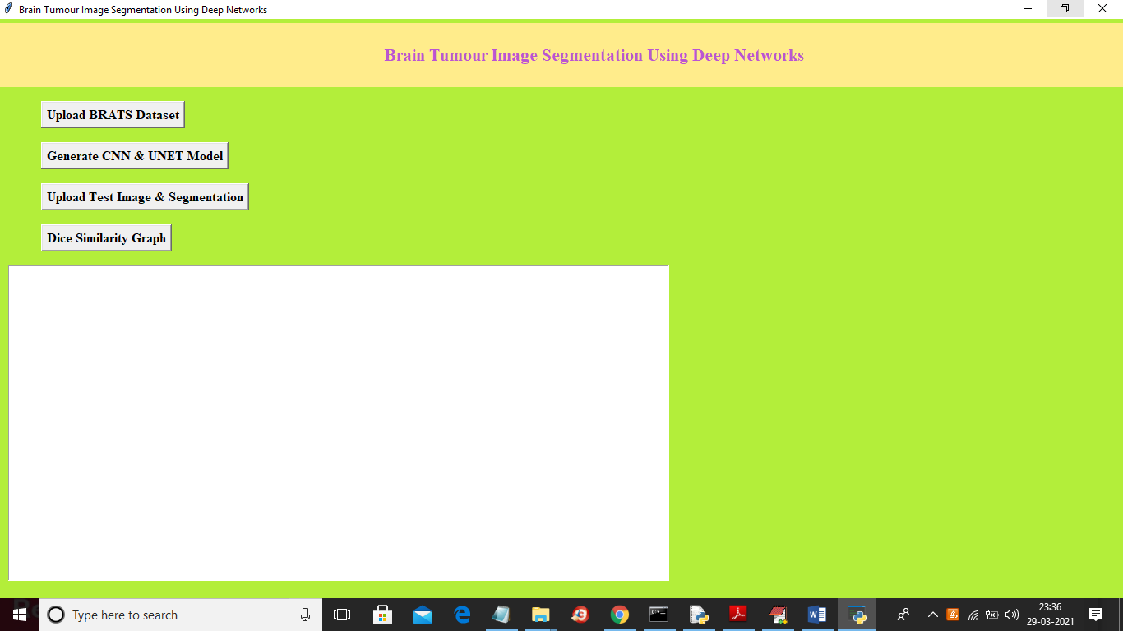

(Fig:3.4.5 User Interface)

In the above screen click on the ‘Upload BRATS Dataset’ button to upload a dataset

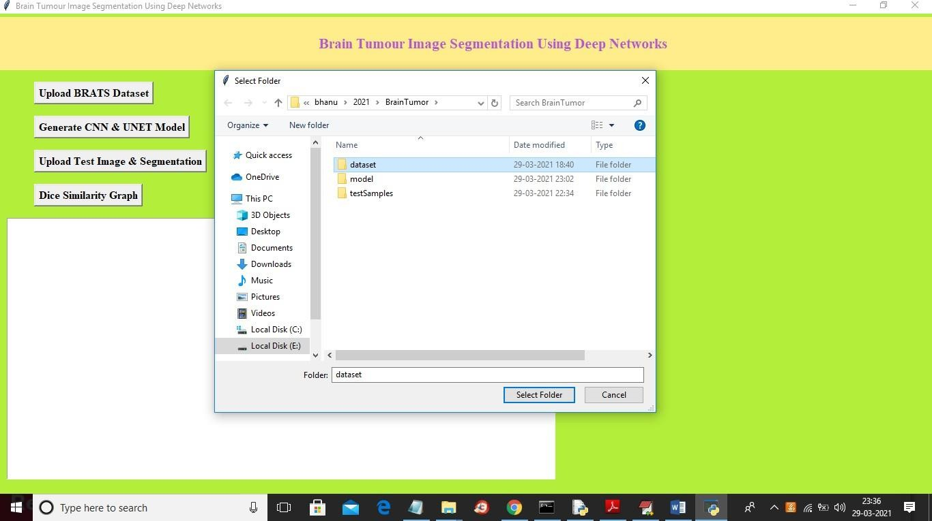

(Fig:3.4.6 Uploading Dataset)

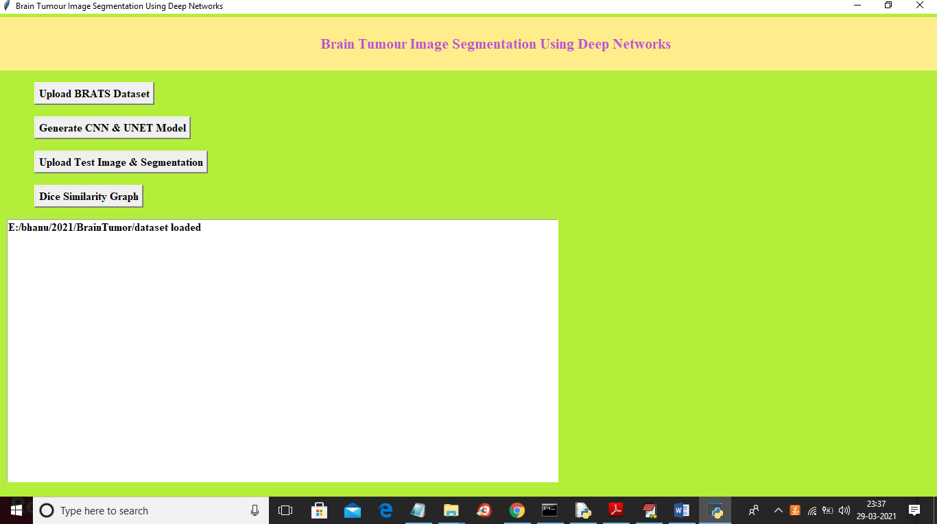In above screen selecting and uploading ‘dataset’ folder and then click on ‘Select Folder’ button to load dataset and to get below screen

(Fig:3.4.7 Dataset Uploaded)

In the above screen dataset loaded and now click on the ‘Generate CNN & UNET Model’ button to generate models and to get the below screen

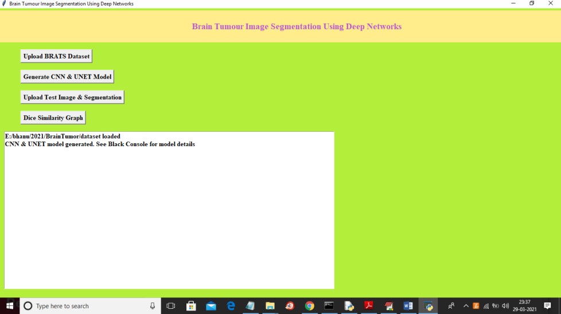

(Fig:3.4.8 Generating Model)

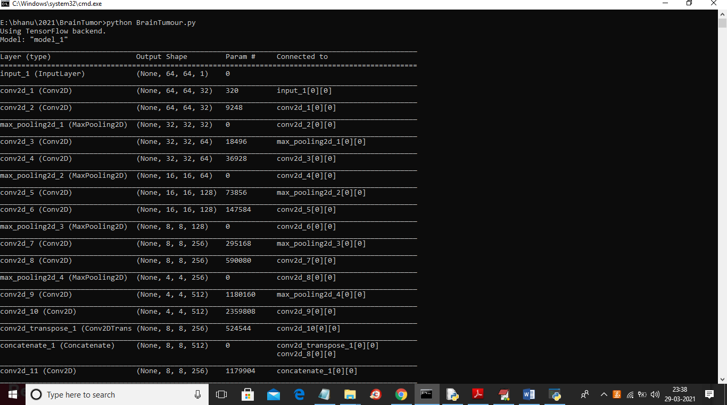In the above screen we can see both models are generated and we can see below the black console to see CNN and UNET layer details

(Fig:3.4.9 Output, Shape, Parms)

In the above screen, we can see models are using different size images to filter them and to get the best features from it to build an efficient model now model is generated and now click on the ‘Upload Test Image & Segmentation’ button and then upload test samples to get segmented output

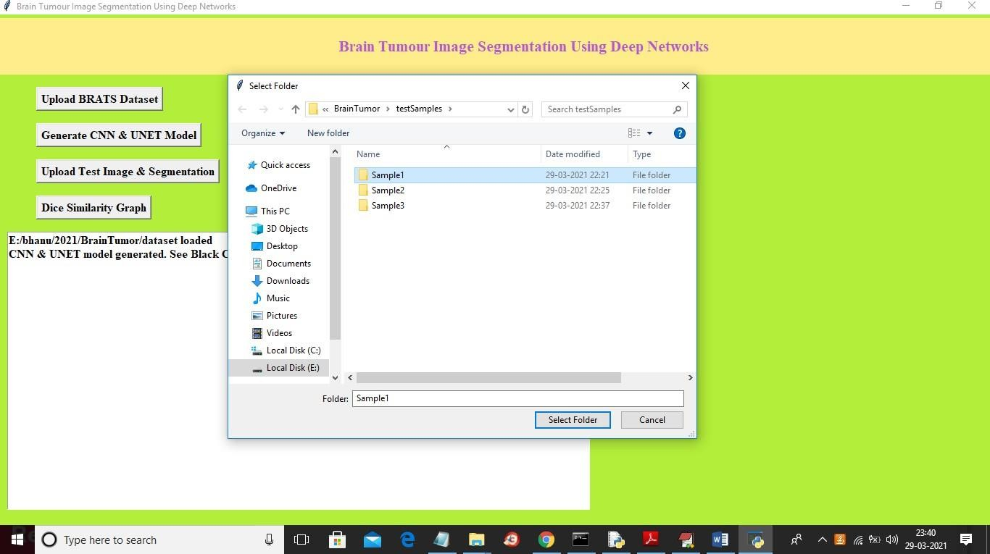

(Fig:3.4.10 Uploading Sample Dataset)

In above screen selecting and uploading ‘Sample1’ folder and then click on ‘Select Folder’ button to get below output.

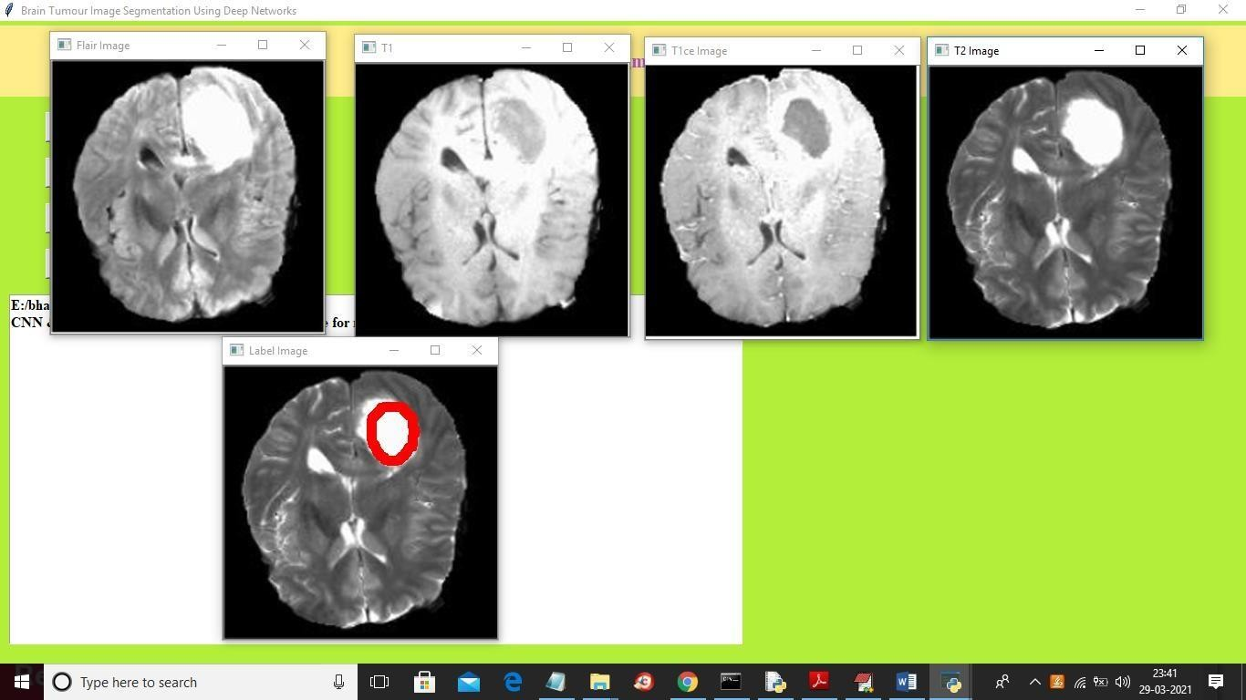

(Fig:3.4.11 Segmentation of MRI Scans)

On the screen above, you can see the top 4 images which are the input images - FLAIR, T1, T2 and T1CE. The 5th image is the predicted image, with the segmented part shown in red. This algorithm accurately detects and marks the tumor area. Now, let's test it with another image.

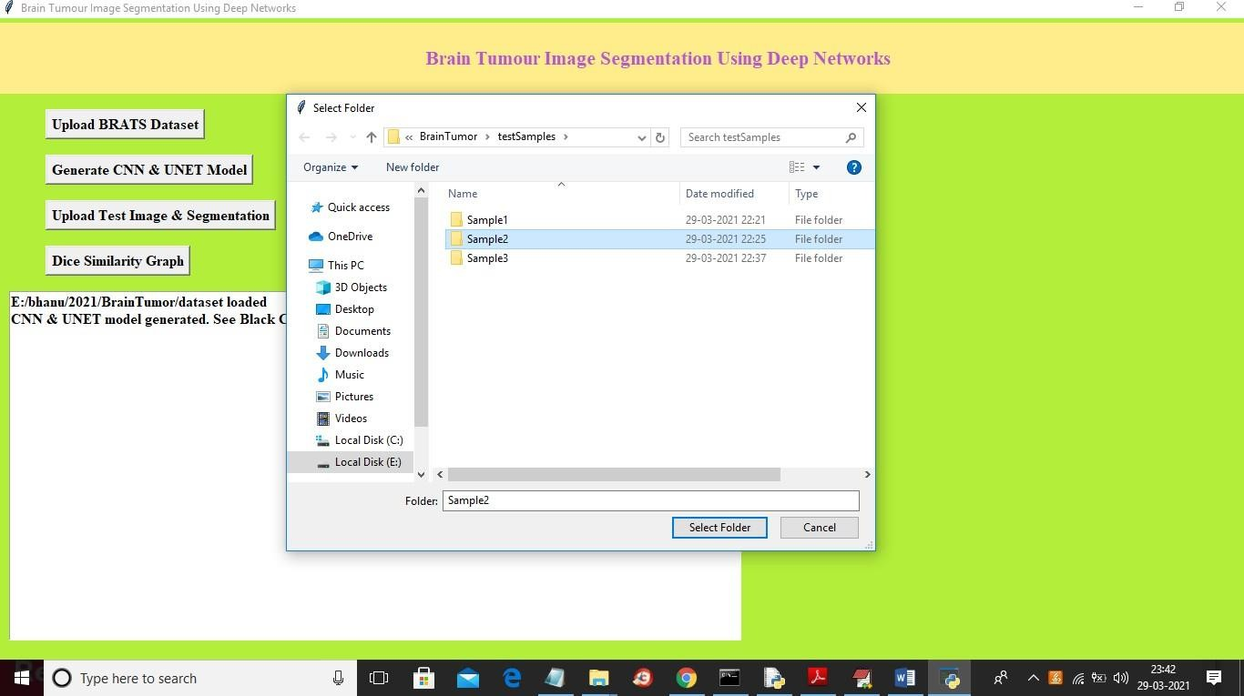

(Fig:3.4.12 Uploading Sample Dataset-2)

In above screen I am selecting and uploading the ‘Sample2’ folder and then click on ‘Select Folder’ button to load images and to get below output

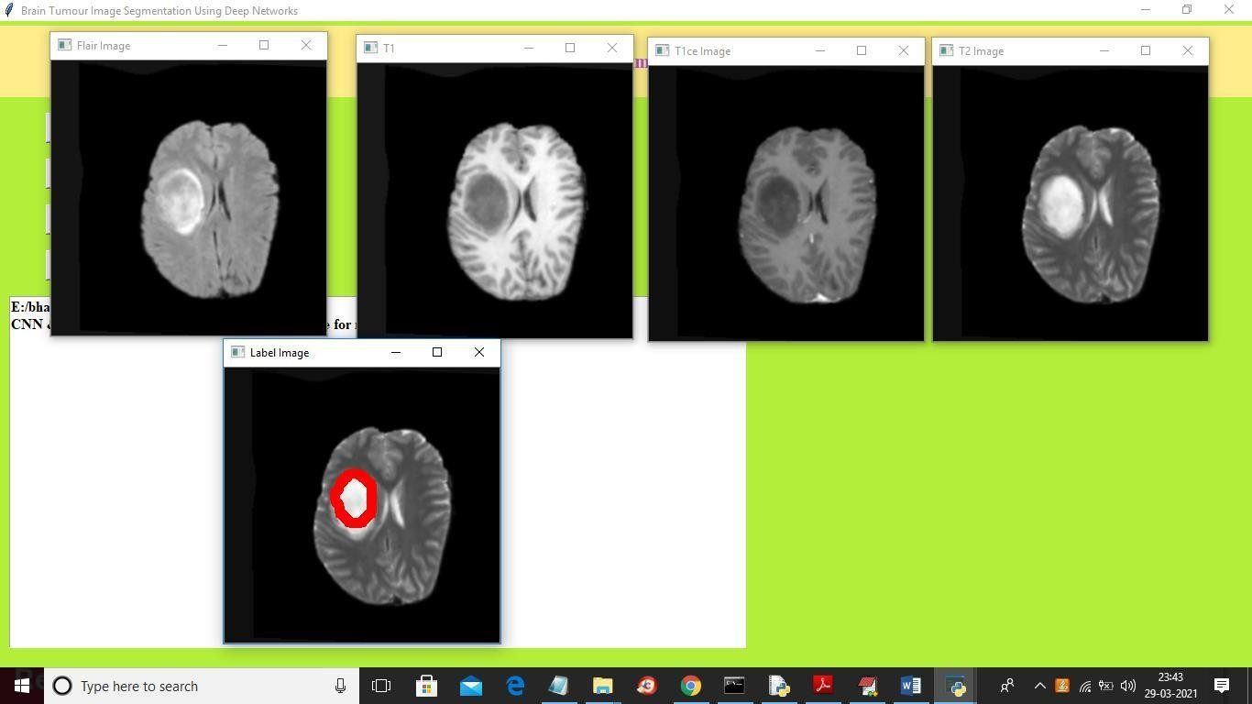

(Fig:3.4.13 Segmentation of Sample Dataset-2)

# CHAPTER 4

## RESULTS AND DISCUSSION

### CHAPTER 4 RESULTS AND DISCUSSION

###### Results Obtained

On the screen above, you can see four images displayed as input. The fifth image shows the predicted label image with segmented parts around the tumor area. To view the Dice Similarity Graph, click on the 'Dice Similarity Graph' button below.

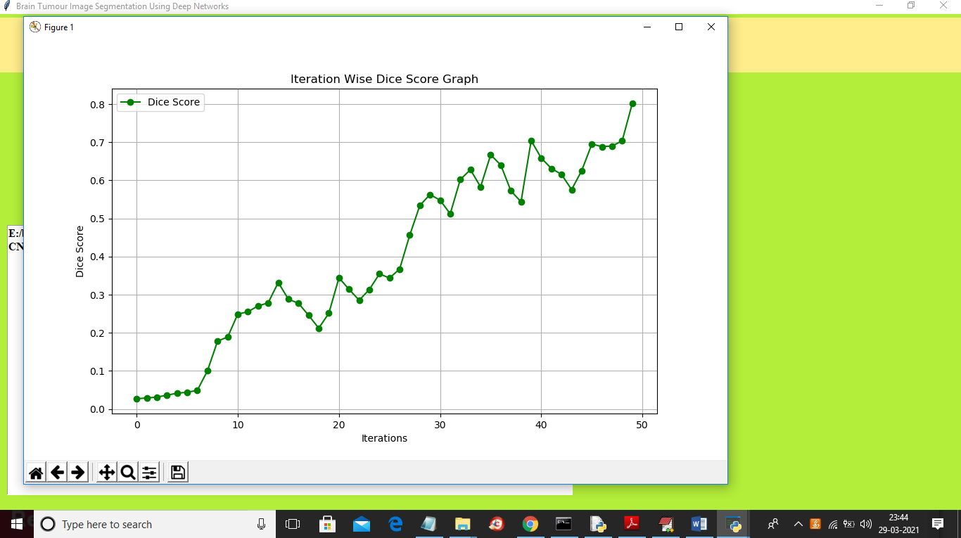

(Fig:4.1.1 Dice Score Graph)

We built a CNN and UNET model with 50 epochs or iterations. At each iteration, the DICE score between the training and testing images improved, resulting in a final DICE score of 80% (0.8 x 100).In the graph above, the x-axis represents the epoch, and the y-axis represents the DICE score.

# CHAPTER 5

## CONCLUSION

#### Conclusions:

**Automation and Efficiency:**

#### CHAPTER 5 CONCLUSION

The automated segmentation approach significantly streamlines the process of identifying and delineating tumor regions in MRI scans. This reduces the reliance on manual segmentation, which can be time-consuming and susceptible to human error.

###### Clinical Utility:

The U-Net-based segmentation method holds great promise in a clinical setting. It provides medical professionals with a powerful tool for accurate and efficient diagnosis and monitoring of brain tumors.

###### Potential for Early Detection:

Early detection of brain tumors is crucial for timely medical interventions. The automated segmentation method enhances the potential for early detection, which can lead to improved patient outcomes.

###### Scalability and Adaptability:

The deep learning-based approach employed in this project offers scalability and adaptability. With additional data and appropriate fine-tuning, the model can potentially be extended to address other types of tumors or even applied to different medical imaging tasks.

###### Ethical Considerations:

The project places significant emphasis on ethical considerations, including patient privacy, data security, and obtaining informed consent. These aspects are critical in maintaining the highest standards of patient care and research integrity.

# CHAPTER 6

## REFERENCES

#### REFERENCES

* + 1. Ronneberger, O., Fischer, P., & Brox, T. (2015). U-Net: Convolutional Networks for Biomedical Image Segmentation. International Conference on Medical Image Computing and Computer-Assisted Intervention (MICCAI), 234-241.
    2. Litjens, G., Kooi, T., Bejnordi, B. E., Setio, A. A. A., Ciompi, F., Ghafoorian, M., ... & Sánchez, C. I. (2017). A survey on deep learning in medical image analysis. Medical Image Analysis, 42, 60-88.
    3. Greenspan, H., van Ginneken, B., & Summers, R. M. (2016). Guest editorial deep
    4. Wu, B., et al. (2024). Interactive medical image annotation using improved Attention U-net with compound geodesic distance. Expert Systems with Applications, 237, 121282.
    5. Nguyen, P. X., et al. (2019). Medical image segmentation with stochastic aggregated loss in a unified u-net. In 2019 IEEE EMBS International Conference on Biomedical & Health Informatics (BHI) (pp. 1-4). IEEE.
    6. Huang, C., et al. (2019). 3D U 2-Net: A 3D universal U-Net for multi-domain medical image segmentation. In International Conference on Medical Image Computing and Computer-Assisted Intervention 2019 (pp. 291-299). Cham: Springer International Publishing.
    7. Lu, H., et al. (2022). Half-UNet: A simplified U-Net architecture for medical image segmentation. Frontiers in Neuroinformatics, 16, 911679.
    8. Arora, A., et al. (2021). Brain tumor segmentation of MRI images using processed image driven u-net architecture. Computers, 10(11), 139.
    9. Zahra, E., et al. (2020). Medical image segmentation using a U-Net type of architecture. arXiv preprint arXiv:2005.05218.
    10. Zhuang, J. (2018). LadderNet: Multi-path networks based on U-Net for medical image segmentation. arXiv preprint arXiv:1810.07810.
    11. Ali, O., et al. (2022). Implementation of a modified U-Net for medical image segmentation on edge devices. IEEE Transactions on Circuits and Systems II: Express Briefs, 69(11), 4593- 4597.
    12. Isensee, F., et al. (2018). nnu-net: Self-adapting framework for u-net-based medical image segmentation. arXiv preprint arXiv:1809.10486.
    13. Hazarika, R. A., et al. (2022). Hippocampus segmentation using U-net convolutional network from brain magnetic resonance imaging (MRI). Journal of Digital Imaging, 35(4), 893- 909.
    14. Sun, J., et al. (2020). Saunet: Shape attentive u-net for interpretable medical image segmentation. In Medical Image Computing and Computer Assisted Intervention–MICCAI 2020 (pp. 797-806). Springer International Publishing.
    15. Siddique, N., et al. (2020). U-Net and its variants for medical image segmentation: theory and applications. arXiv preprint arXiv:2011.01118.
    16. Du, G., et al. (2020). Medical image segmentation based on u-net: A review. Journal of Imaging Science and Technology, 64(5), 50301.
    17. Siddique, N., et al. (2021). U-net and its variants for medical image segmentation: A reviewof theory and applications. IEEE Access, 9, 82031-82057.
    18. Alom, M. Z., et al. (2019). Recurrent residual U-Net for medical image segmentation. Journal of Medical Imaging, 6(1), 014006.
    19. Wei, J., et al. (2021). Genetic U-Net: automatically designed deep networks for retinal vessel segmentation using a genetic algorithm. IEEE Transactions on Medical Imaging, 41(2), 292-307.

1. Yin, X. X., et al. (2022). U-Net-Based medical image segmentation. Journal of Healthcare Engineering, 2022.
2. Zheng, P., et al. (2022). Brain tumour segmentation based on an improved U-Net. BMC Medical Imaging, 22(1), 1-9.
3. Chetty, G., et al. (2022). A low resource 3D U-Net based deep learning model for medical image analysis. International Journal of Information Technology, 14(1), 95-103.
4. Kermi, A., et al. (2019). Deep convolutional neural networks using U-Net for automatic brain tumor segmentation in multimodal MRI volumes. In Brainlesion: Glioma, Multiple Sclerosis, Stroke and Traumatic Brain Injuries (pp. 37-48). Springer International Publishing.
5. Chen, W., et al. (2022). Deep learning-based medical image segmentation of the aorta using XR-MSF-U-Net. Computer Methods and Programs in Biomedicine, 225, 107073.
6. Jwaid, W. M., et al. (2021). DEVELOPMENT OF BRAIN TUMOR SEGMENTATION OF MAGNETIC RESONANCE IMAGING (MRI) USING U-NET DEEP LEARNING. Eastern- European Journal of Enterprise Technologies, 112.
7. Deng, Y., et al. (2022). ELU-net: an efficient and lightweight U-net for medical image segmentation. IEEE Access, 10, 35932-35941.

# CHAPTER 7

## APPENDIX

###### 7.1 Project Code:

**Importing Libraries**

from tkinter import messagebox from tkinter import *

from tkinter import simpledialog import tkinter

from tkinter import simpledialog from tkinter import filedialog import numpy as np

from tkinter.filedialog import askopenfilename import pickle

import os import cv2

import matplotlib.pyplot as plt

from sklearn.model_selection import train_test_split

from keras.models import * from keras.layers import * from keras.optimizers import *

gui = tkinter.Tk()

gui.title("Brain Tumour Image Segmentation Using Deep Networks") gui.geometry("1300x1200")

global filename global model global X, Y

###### Calculating Dice Coefficient

def dice_coef(y_true, y_pred): y_true_f = keras.flatten(y_true) y_pred_f = keras.flatten(y_pred)

intersection = keras.sum(y_true_f * y_pred_f)

return (2. * intersection + 1) / (keras.sum(y_true_f) + keras.sum(y_pred_f) + 1)

def dice_coef_loss(y_true, y_pred): return -dice_coef(y_true, y_pred)

def getModel(input_size=(64,64,1)): inputs = Input(input_size)

conv1 = Conv2D(32, (3, 3), activation='relu', padding='same')(inputs) conv1 = Conv2D(32, (3, 3), activation='relu', padding='same')(conv1) pool1 = MaxPooling2D(pool_size=(2, 2))(conv1)

conv2 = Conv2D(64, (3, 3), activation='relu', padding='same')(pool1)

conv2 = Conv2D(64, (3, 3), activation='relu', padding='same')(conv2) pool2 = MaxPooling2D(pool_size=(2, 2))(conv2)

conv3 = Conv2D(128, (3, 3), activation='relu', padding='same')(pool2) conv3 = Conv2D(128, (3, 3), activation='relu', padding='same')(conv3) pool3 = MaxPooling2D(pool_size=(2, 2))(conv3)

conv4 = Conv2D(256, (3, 3), activation='relu', padding='same')(pool3) conv4 = Conv2D(256, (3, 3), activation='relu', padding='same')(conv4) pool4 = MaxPooling2D(pool_size=(2, 2))(conv4)

conv5 = Conv2D(512, (3, 3), activation='relu', padding='same')(pool4) conv5 = Conv2D(512, (3, 3), activation='relu', padding='same')(conv5)

up6 = concatenate([Conv2DTranspose(256, (2, 2), strides=(2, 2), padding='same')(conv5), conv4], axis=3)

conv6 = Conv2D(256, (3, 3), activation='relu', padding='same')(up6) conv6 = Conv2D(256, (3, 3), activation='relu', padding='same')(conv6)

up7 = concatenate([Conv2DTranspose(128, (2, 2), strides=(2, 2), padding='same')(conv6), conv3], axis=3)

conv7 = Conv2D(128, (3, 3), activation='relu', padding='same')(up7) conv7 = Conv2D(128, (3, 3), activation='relu', padding='same')(conv7)

up8 = concatenate([Conv2DTranspose(64, (2, 2), strides=(2, 2), padding='same')(conv7), conv2], axis=3)

conv8 = Conv2D(64, (3, 3), activation='relu', padding='same')(up8) conv8 = Conv2D(64, (3, 3), activation='relu', padding='same')(conv8)

up9 = concatenate([Conv2DTranspose(32, (2, 2), strides=(2, 2), padding='same')(conv8), conv1], axis=3)

conv9 = Conv2D(32, (3, 3), activation='relu', padding='same')(up9) conv9 = Conv2D(32, (3, 3), activation='relu', padding='same')(conv9)

conv10 = Conv2D(1, (1, 1), activation='sigmoid')(conv9) return Model(inputs=[inputs], outputs=[conv10])

###### Uploading the dataset

def uploadDataset(): global X, Y global filename text.delete('1.0', END)

filename = filedialog.askdirectory(initialdir=".")

text.insert(END,filename+" loaded\n"); X = []

Y = []

for root, dirs, directory in os.walk(filename): for i in range(len(directory)):

img = cv2.imread(train_directory+"/"+directory[i],0)

img = cv2.resize(img,(64,64), interpolation = cv2.INTER_CUBIC) X.append(img)

img = cv2.imread("dataset/label/"+directory[i],0)

img = cv2.resize(img,(64,64), interpolation = cv2.INTER_CUBIC) Y.append(img)

X = np.asarray(X)Y

= np.asarray(Y)

###### Generating the model

def generateModel(): global model global X, Y

dim = 64

X_train, X_test, y_train, y_test = train_test_split(X, Y, test_size = 0.10, random_state = 1) X_train = X_train.reshape(len(X_train),dim,dim,1)

y_train = y_train.reshape(len(y_train),dim,dim,1) X_test = X_test.reshape(len(X_test),dim,dim,1) y_test = y_test.reshape(len(y_test),dim,dim,1) images = np.concatenate((X_train,X_test),axis=0) mask = np.concatenate((y_train,y_test),axis=0) tr = X_train[12] yr

= y_train[12] cv2.imshow('tr',tr)

cv2.imshow('yr',yr) cv2.waitKey(0)

model = getModel(input_size=(64,64,1))

with open('model/model.json', "r") as json_file: loaded_model_json = json_file.read()

model = model_from_json(loaded_model_json) json_file.close() model.load_weights("model/model_weights.h5") model._make_predict_function() print(model.summary())

text.insert(END,"CNN & UNET model generated. See Black Console for model details\n") model.compile(optimizer=Adam(lr=1e-5), loss=dice_coef_loss, metrics=[dice_coef,

'binary_accuracy']) print(model.summary())

model.compile(optimizer=Adam(lr=2e-4), loss=[dice_coef_loss], metrics = [dice_coef,

'binary_accuracy'])

train_vol, validation_vol, train_seg, validation_seg = train_test_split((images-127.0)/127.0,

(mask>127).astype(np.float32), test_size = 0.1,random_state = 2018)

train_vol, test_vol, train_seg, test_seg = train_test_split(train_vol,train_seg,

test_size = 0.1,

random_state = 2018)

hist = model.fit(x = train_vol, y = train_seg, batch_size = 16, epochs = 50, validation_data

=(test_vol,test_seg)) model.save_weights('model/model_weights.h5') model_json = model.to_json()

with open("model/model.json", "w") as json_file: json_file.write(model_json)

f = open('model/history.pckl', 'wb') pickle.dump(hist.history, f) f.close()

###### Segmentation task

def getSegmentation():

img = cv2.imread('myimg.png') orig = cv2.imread('test1.png')

gray = cv2.cvtColor(img, cv2.COLOR_BGR2GRAY)

thresh = cv2.threshold(gray, 30, 255, cv2.THRESH_BINARY)[1]

contours = cv2.findContours(thresh, cv2.RETR_TREE, cv2.CHAIN_APPROX_SIMPLE) contours = contours[0] if len(contours) == 2 else contours[1]

min_area = 0.95*180*35 max_area = 1.05*180*35 result = orig.copy()

for c in contours:

area = cv2.contourArea(c) cv2.drawContours(result, [c], -1, (0, 0, 255), 10)if area > min_area and area < max_area:

cv2.drawContours(result, [c], -1, (0, 255, 255), 10) return result

def TumourSegmentation(): global model

filename = filedialog.askdirectory(initialdir="testSamples") img = cv2.imread(str(filename)+'/t2.png',0)

img = cv2.resize(img,(64,64), interpolation = cv2.INTER_CUBIC) img = img.reshape(1,64,64,1)

img = (img-127.0)/127.0 preds = model.predict(img) preds = preds[0] print(preds.shape)

orig = cv2.imread(str(filename)+'/t2.png',0)

orig = cv2.resize(orig,(300,300),interpolation = cv2.INTER_CUBIC)

cv2.imwrite("test1.png",orig)

flair = cv2.imread(str(filename)+'/flair.png',0)

flair = cv2.resize(flair,(300,300),interpolation = cv2.INTER_CUBIC)t1

= cv2.imread(str(filename)+'/t1.png',0)

t1 = cv2.resize(t1,(300,300),interpolation = cv2.INTER_CUBIC) t1ce = cv2.imread(str(filename)+'/t1ce.png',0)

t1ce = cv2.resize(t1ce,(300,300),interpolation = cv2.INTER_CUBIC)

preds = cv2.resize(preds,(300,300),interpolation = cv2.INTER_CUBIC) cv2.imwrite("myimg.png",preds*255)

preds = getSegmentation() cv2.imshow('Flair Image',flair) cv2.imshow('T1',t1) cv2.imshow("T1ce Image",t1ce) cv2.imshow('T2 Image',orig) cv2.imshow("Label Image",preds) cv2.waitKey(0)

###### Generating the graph for Dice Coefficient

def graph():

f = open('model/history.pckl', 'rb') data = pickle.load(f)

f.close()

dice = data['dice_coef'] for i in range(len(dice)): dice[i]

= dice[i] * 2 plt.figure(figsize=(10,6)) plt.grid(True) plt.xlabel('Iterations') plt.ylabel('Dice Score') plt.plot(dice, 'ro-', color = 'green')

plt.legend(['Dice Score'], loc='upper left') #plt.xticks(wordloss.index) plt.title('Iteration Wise Dice Score Graph') plt.show()

###### Making UI with tkinter

font = ('times', 16, 'bold')

title = Label(gui, text='Brain Tumour Image Segmentation Using Deep Networks') title.config(bg='LightGoldenrod1', fg='medium orchid')

title.config(font=font) title.config(height=3, width=120) title.place(x=0,y=5)

font1 = ('times', 12, 'bold') text=Text(gui,height=20,width=100) scroll=Scrollbar(text) text.configure(yscrollcommand=scroll.set) text.place(x=10,y=300)

text.config(font=font1) font1 = ('times', 12, 'bold')

loadButton = Button(gui, text="Upload BRATS Dataset", command=uploadDataset) loadButton.place(x=50,y=100)

loadButton.config(font=font1)

uploadButton = Button(gui, text="Generate CNN & UNET Model", command=generateModel) uploadButton.place(x=50,y=150)

uploadButton.config(font=font1)

descButton = Button(gui, text="Upload Test Image & Segmentation", command=TumourSegmentation)

descButton.place(x=50,y=200) descButton.config(font=font1)

closeButton = Button(gui, text="Dice Similarity Graph", command=graph) closeButton.place(x=50,y=250)

closeButton.config(font=font1)

gui.config(bg='OliveDrab2') gui.mainloop()

###### GITHUB LINK

**https://github.com/akshay-1209/Medical-Image-Segmentation-For-Brain-Tumor-Detection- Using-U-net-s**

###### DOI

**https://doi.org/10.22214/ijraset.2024.59327**

###### PUBLISHED PAPER



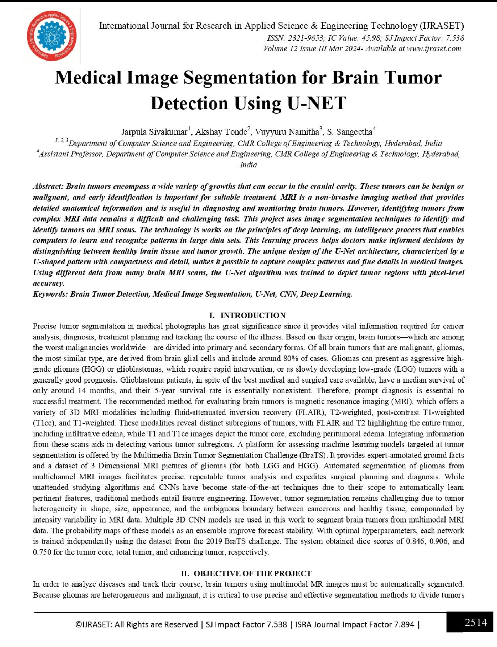

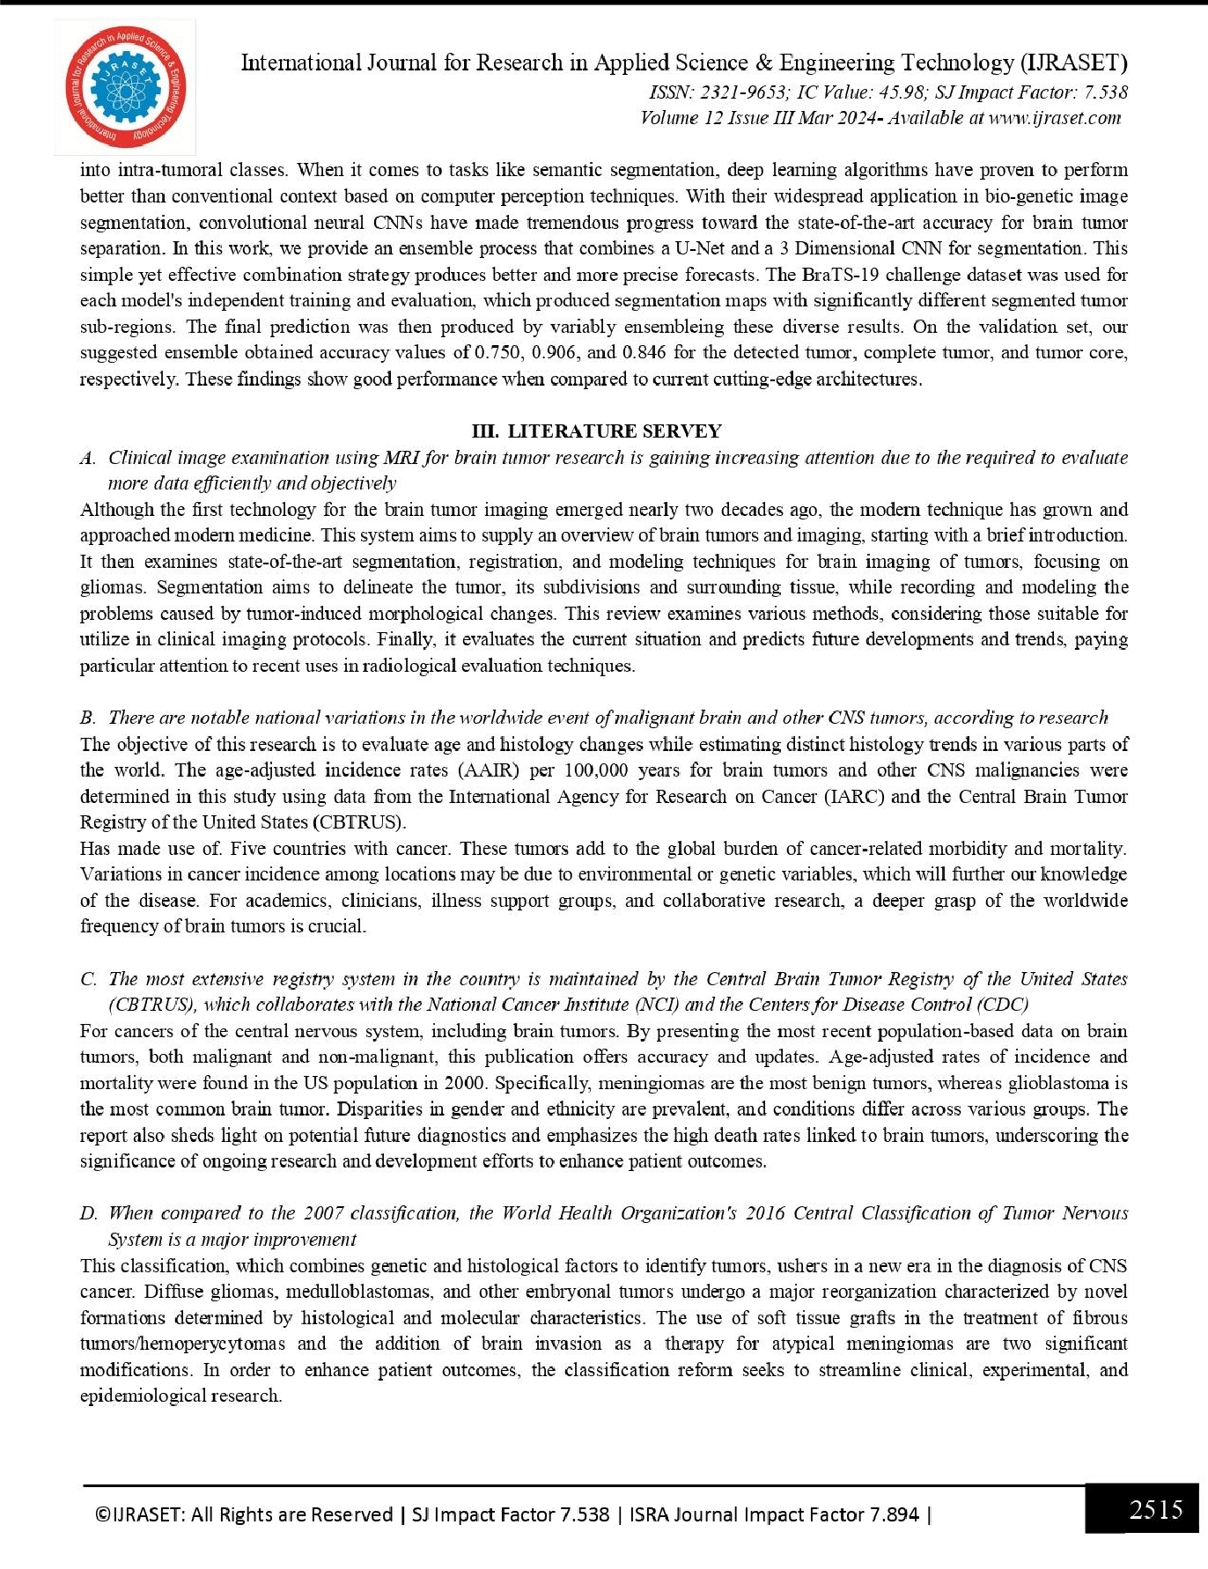

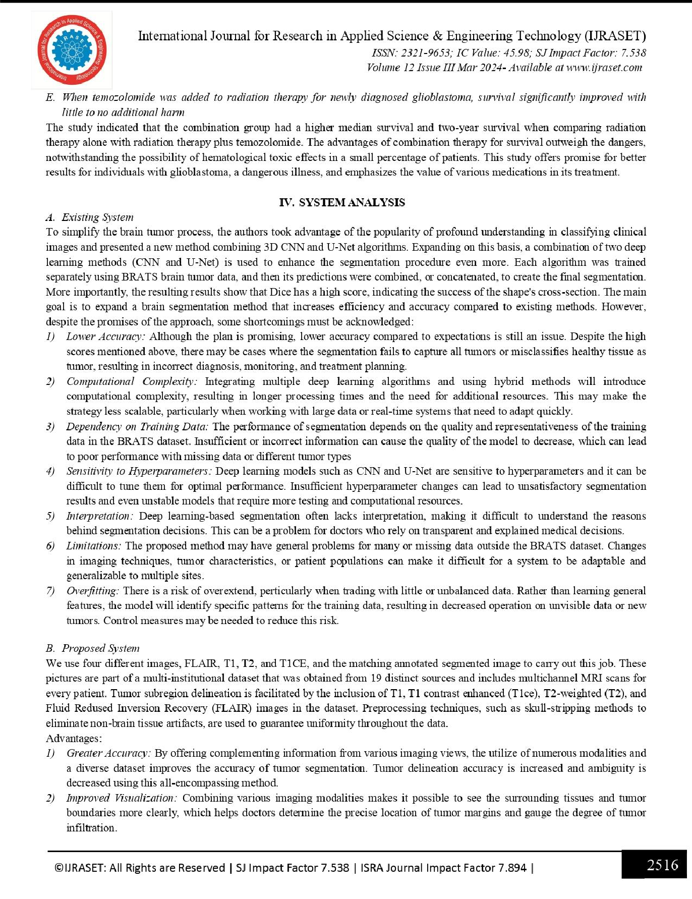

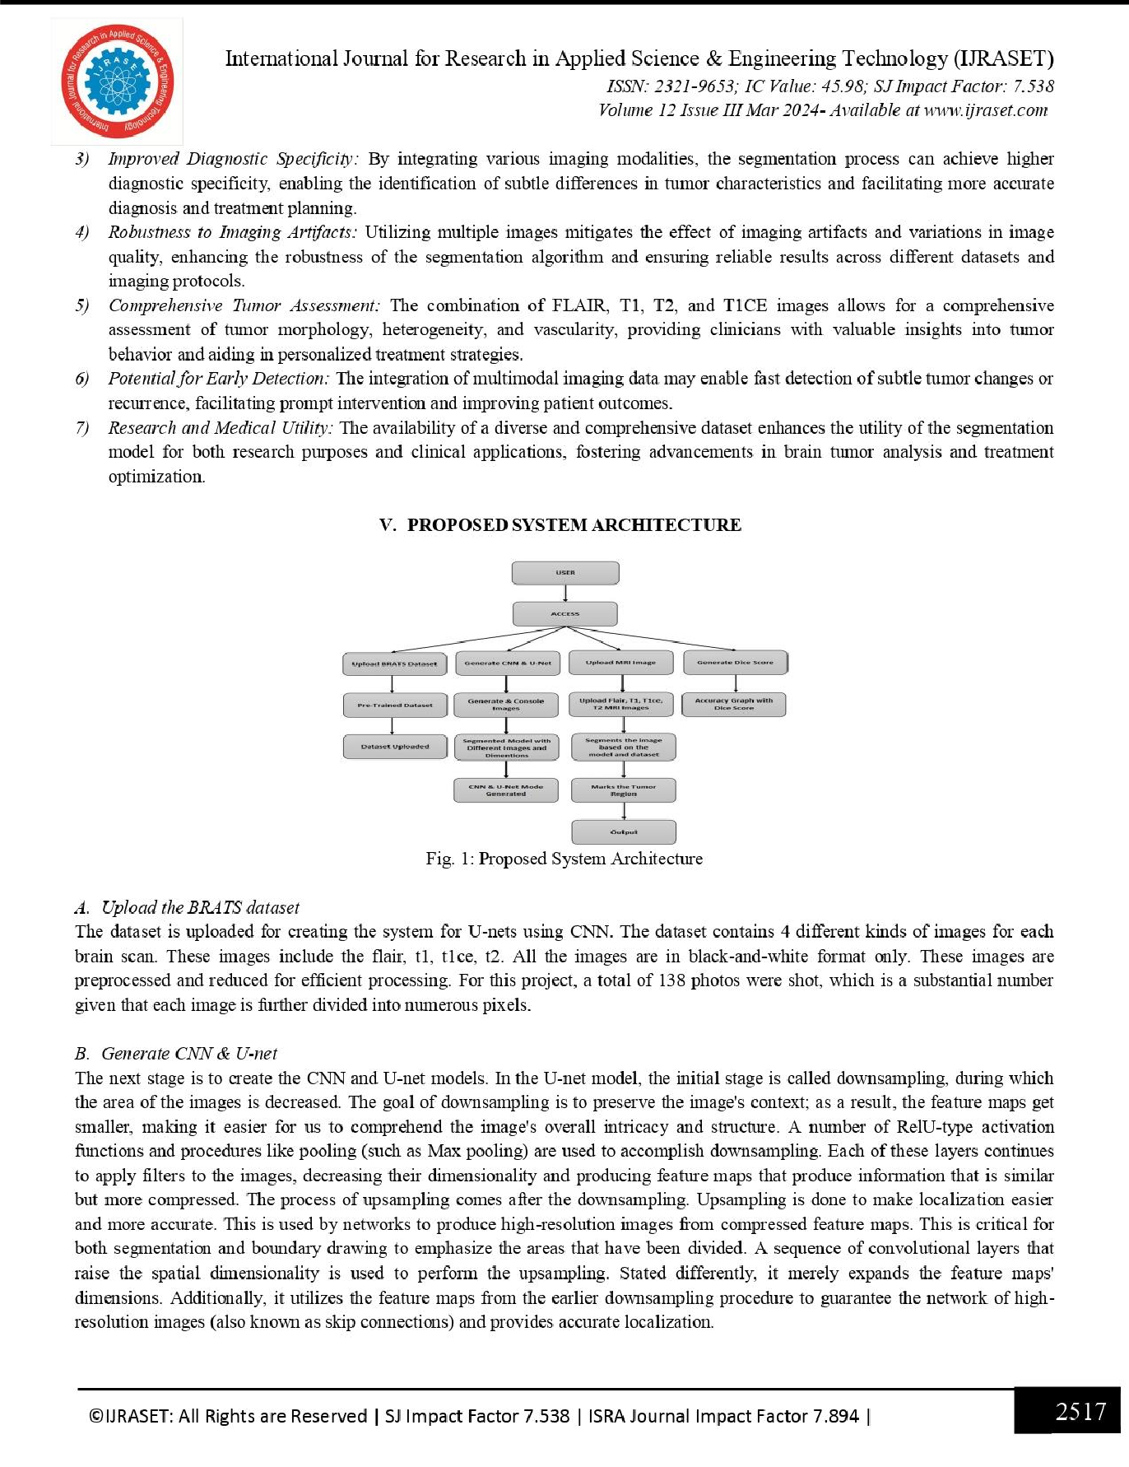

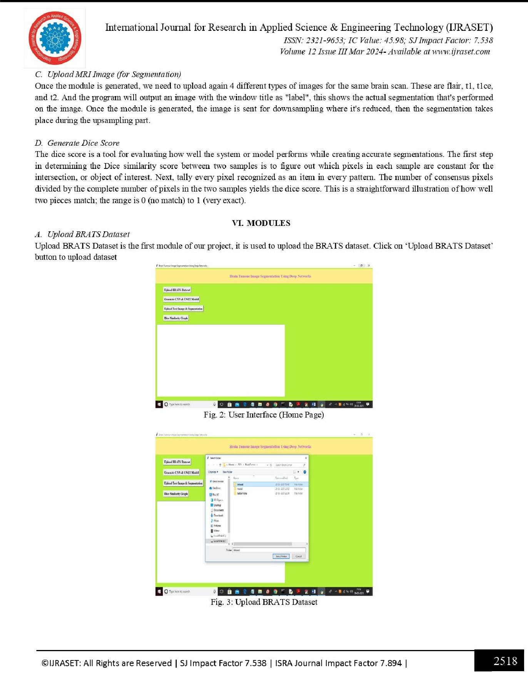

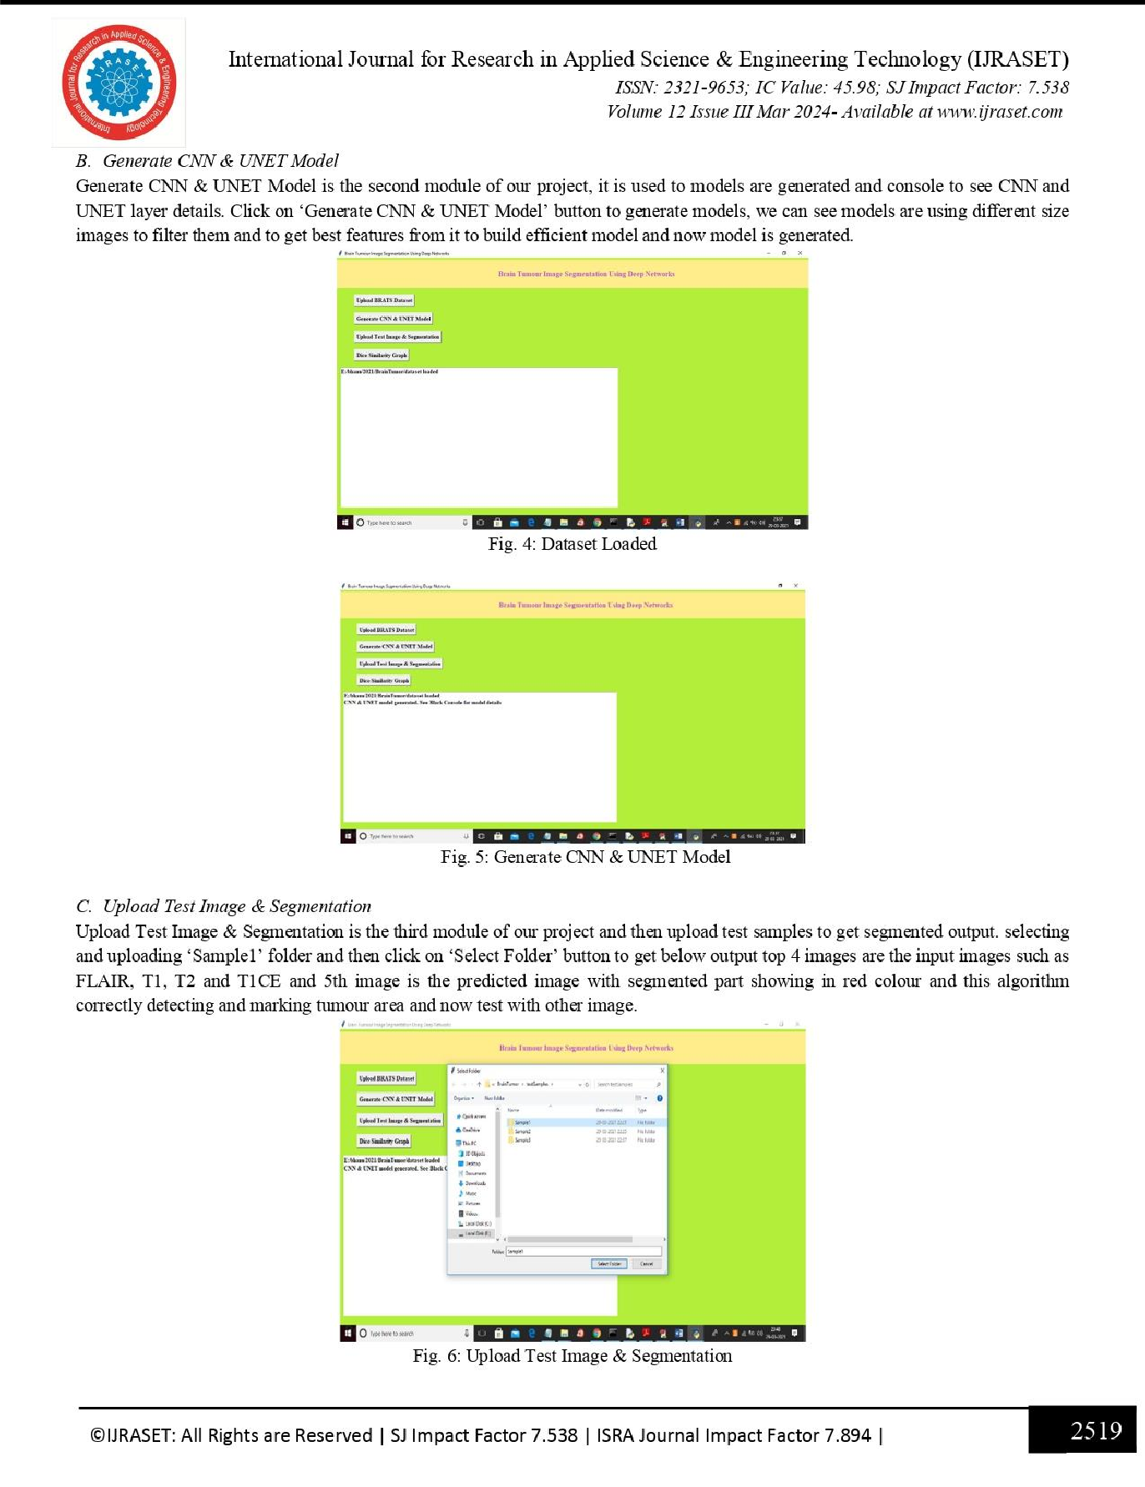

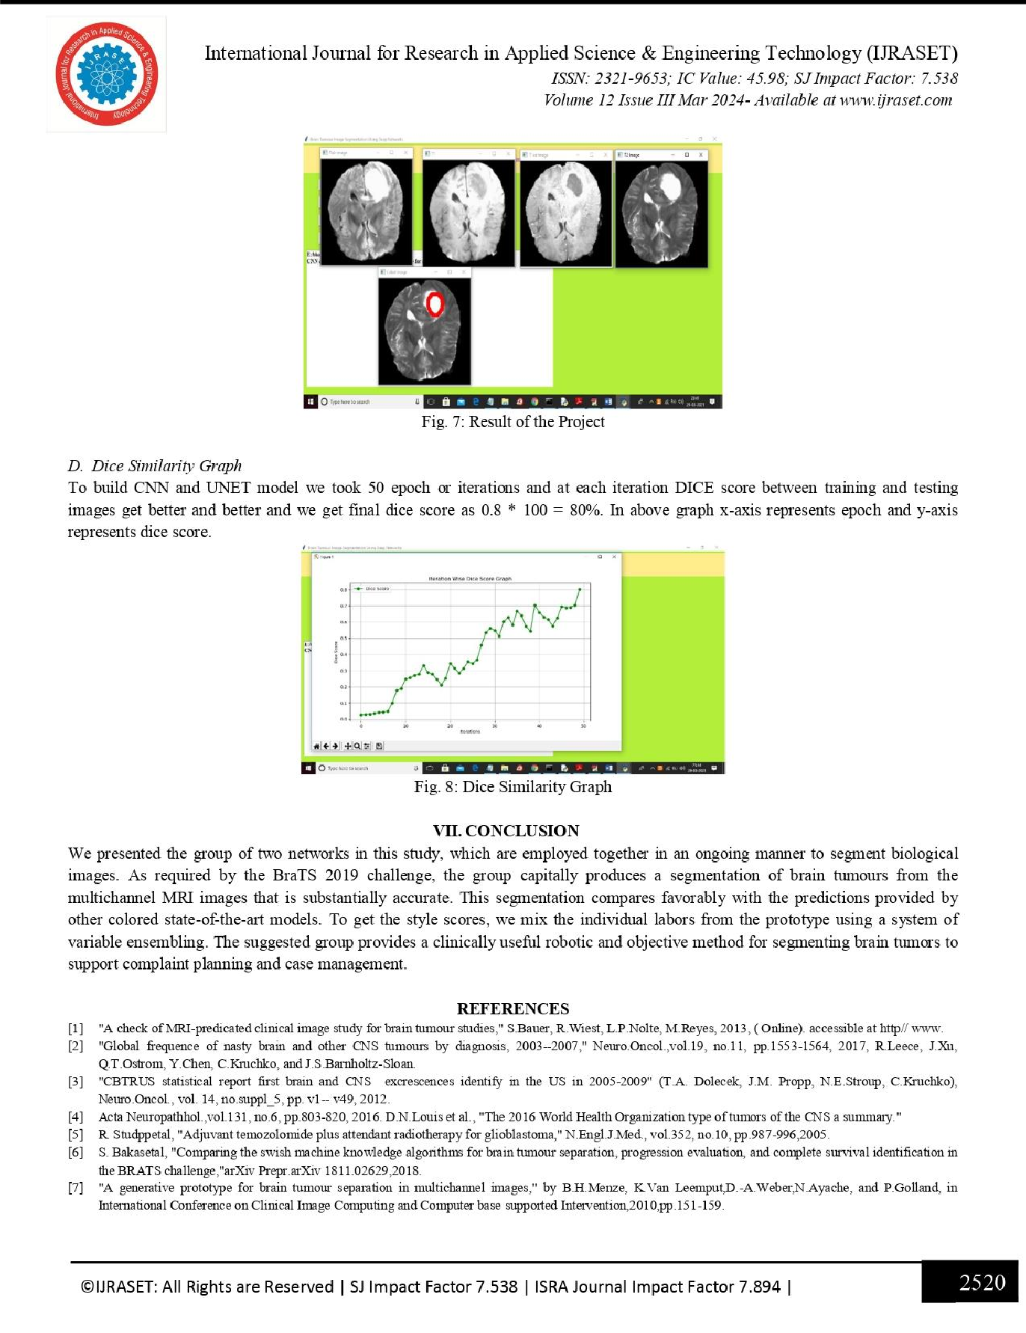

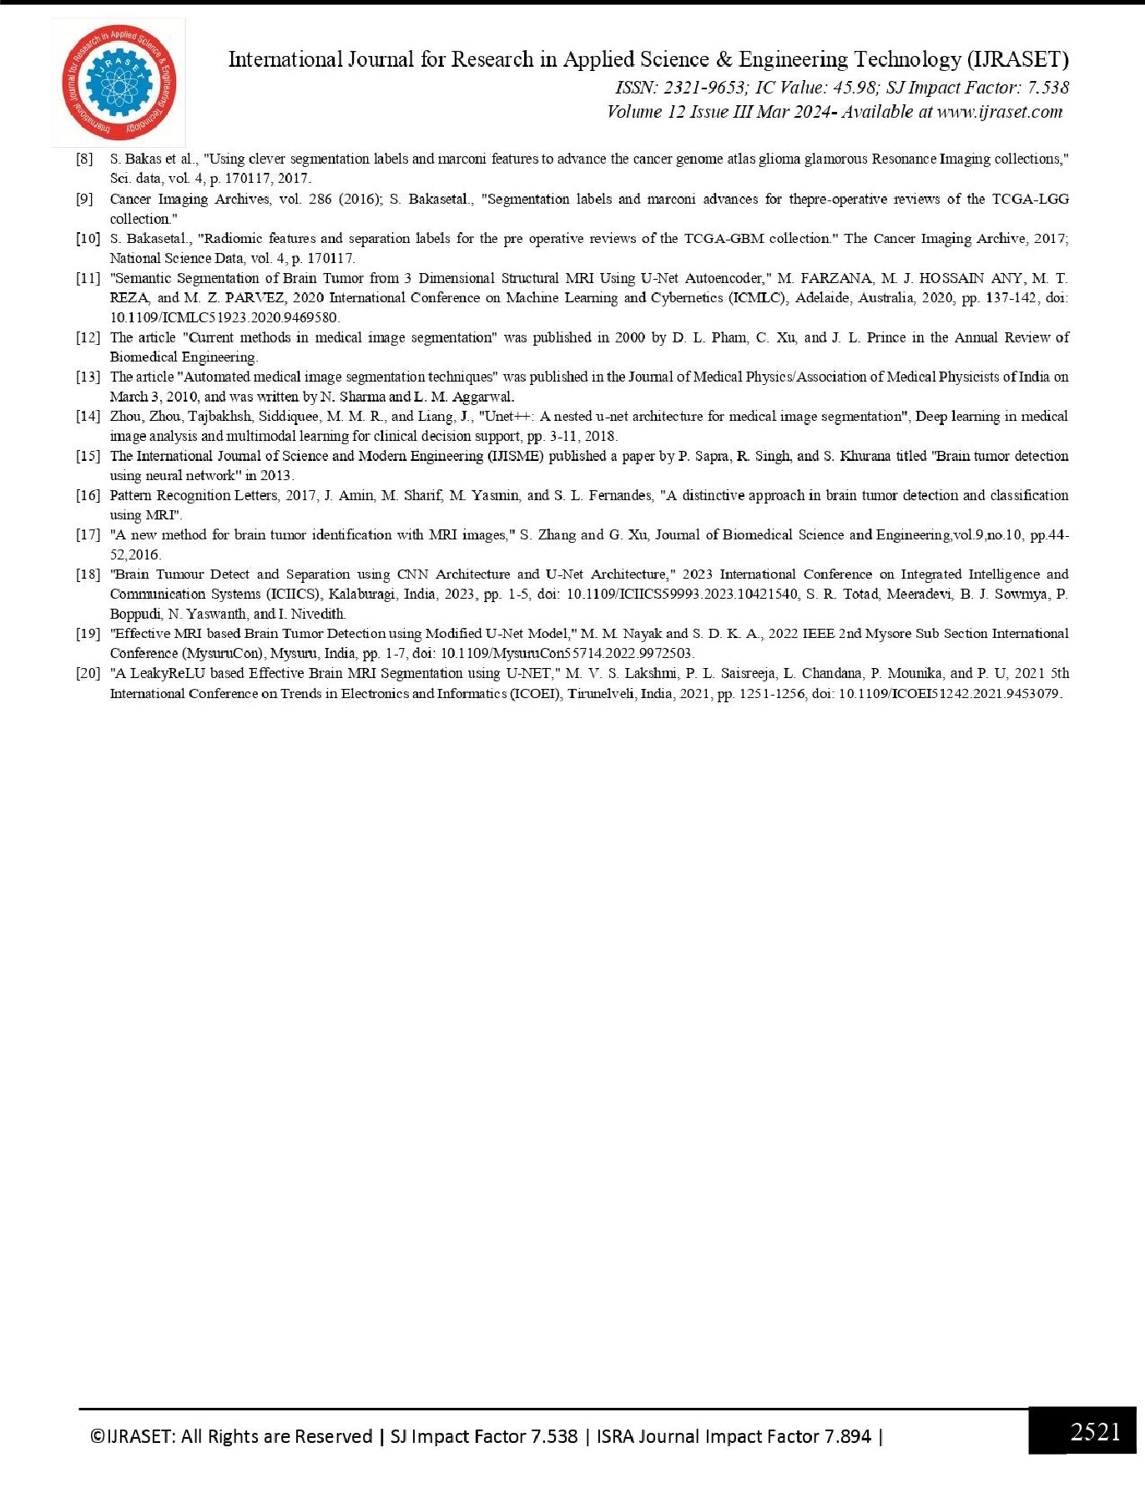



**CERTIFICATES:**

